Archiving Analog Sound to a Digital Format

Some academic uses for converting to digital:

Preserving educational materials before they deteriorate | Cheap, easy distribution of educational materials you have created
Being able to manipulate and edit materials | Recording educational programs from the radio
For younger students, dictation practice | Practicing music for band or other music classes

Step one: preparation
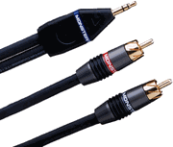
Get an analog source (cassette player, TV, VCR, phonograph) that preferably has the RCA connection (typically red and white color coded). You will need a 1/8th inch stereo to dual RCA connection y-cable (pictured at right).

Next, locate the audio I/O on your computer. The cheaper soundcards will typically have 3 I/O connections (output, microphone, line-in). Connect the 1/8th inch connection from the y-cable to the line-in on the computer. Connect the other two ends of the y-cable to the audio output RCA connections on your audio source.

If your source does not have RCA connections, you may also use the headphone jack as your audio out. Instead of the y-cable, you would only need a straight 1/8th stereo to 1/8th connection (very abundant, often used to connect multimedia speakers to your computer).

Step two: recording
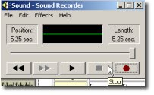
The most basic program you can use to record is the Windows audio recorder (Start>Programs>Accessories>Entertainment>Sound Recorder).

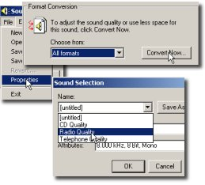
To get a high quality recording that can be used for CD audio, first click “file”, then “properties”, then “convert now”. From the drop down list at the top left, select “CD quality” and click “ok”. You are now ready to record. Click the red record button and click the stop button when you are done. If you are pleased with what you recorded, click “file” and then “save as”.

Troubleshooting techniques will be covered in the presentation.

Step three: using the digital audio for other uses.

The WAV file you recorded and saved is compliant with burning programs to put on an audio CD. When you are ready to burn, simply choose the file you saved, and the burning program will convert it into CD audio.

You can also edit the audio in other programs (the Windows recorder is very weak for editing). Some of the editing possibilities will be covered in the presentation.

Important considerations when converting from analog to digital

- Be sure your analog input is of the highest quality possible. Digital audio editing programs can only fix problems to a certain degree. If cassettes are your source, try to use a player with noise reduction capabilities.
- You will want to adjust the output level of your source, as well as the gain on your input to the optimal level to prevent distortion.
- If a phonograph is your source, check to see if the output is too high. This should not be a problem with new record players.

