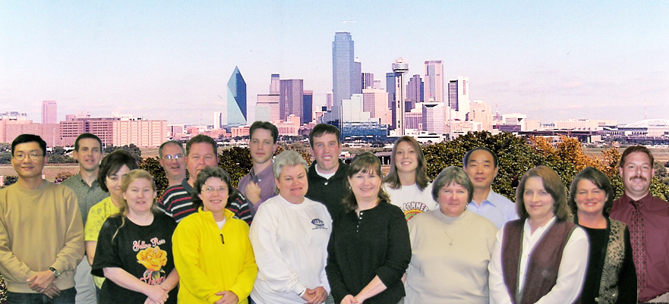
PHOTOSHOP IN A NUTSHELL
Open Photoshop
The palettes will open as they were when Photoshop was last used. So….first thing, go to:
- Window~Workspace~Reset Palette Locations
- Edit~Preferences~Memory (For Windows, subtract 125 from total RAM used)
Set to 70% for 512 RAM (Photoshop will run faster and more efficiently with more RAM)
- Put Palettes in order, close the ones you won’t be using (Get the maximum real estate possible)
- File~New Name document, pick size of document, resolution, background
- Practice - Draw Boxes, Fill, Color, Gradient, Text Box , Add Layer Style
Importing and Manipulating Pictures
- Pictures – Scan in or import from hard drive, other drive, or camera
- Evaluate picture for color correctness, lightness/darkness, size
- Decide what you want to accomplish before you start!
- Make copy of background image before doing anything else
- Layers, name background layer so that it will unlock
- Create New Fill or Adjustment Layer
- Choose what you want to do. When it opens, click okay before starting
- Go to Layer ~ Create clipping mask (“Link with previous”-previous version)
- Click on the icon on the layer and make the change
- For example, to lighten or darken, use curve
- For color correction, use color balance; use hue/saturation for minor color changes
- Pay special attention to the layer you are on
- If a tool is not working, 1st thing check to make sure you are on the correct layer
- If a palette is not showing, go to Window, click on the palette you want
- Name all layers so that there is no confusion later
- Check out filters, text
- Apply image, unsharpen mask, add grain (if digital picture)
- Crop to final size
- Save. Be sure to also save as “psd” (Photoshop file) if you think you might ever want to make changes to this picture again.

