(Laura Dacus’ Technology Presentation for ETEC 562)
Getting started with Microsoft Producer:

NOTE:
Before beginning a new project in Producer, it is a good idea to create a folder on your desktop for your project and save all files, images, sounds, and PowerPoint presentations that you intend to use in Producer. Producer is like the “glue” that brings it all together!

STARTING A NEW PROJECT:
Click “Start” –go to “Programs” and select “MS Producer”.

When you open Producer and begin a new project you will see this screen:
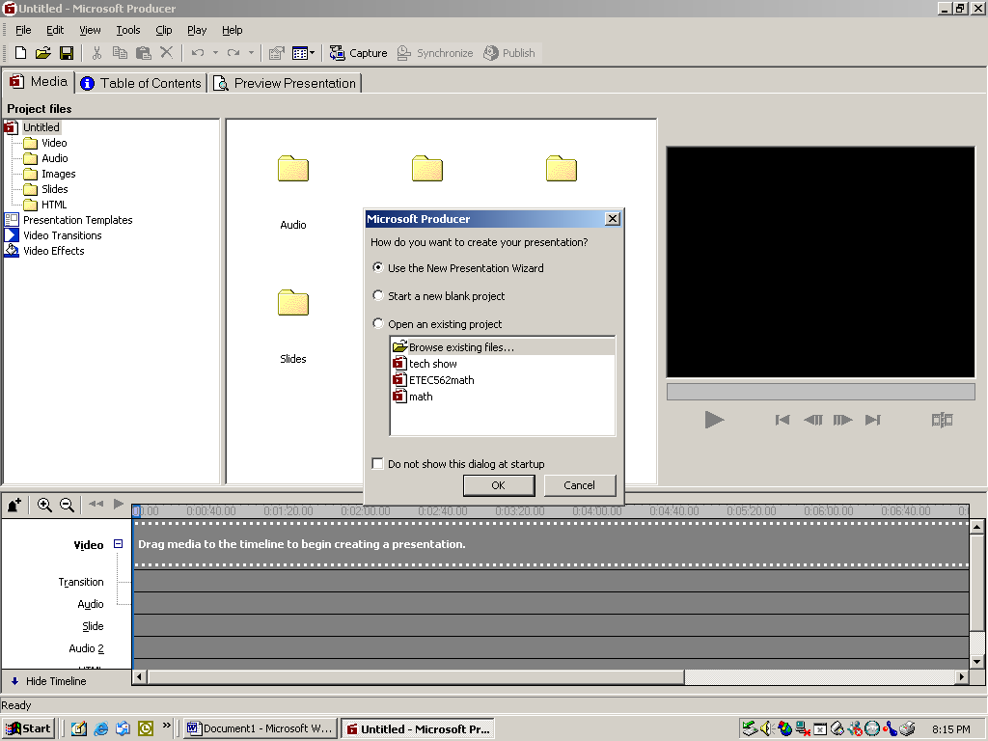

Using the Presentation Wizard is good for first time efforts; however, the program is so intuitive that even a novice can choose “Start a new blank project”.

If you use the wizard, then follow the on screen steps. These are pretty self explanatory. As mentioned before, is it good to have everything saved in one folder before you begin. The wizard will ask for the location of your audio, video, images, and power points.

If you choose to cancel the wizard then the screen will look like this:
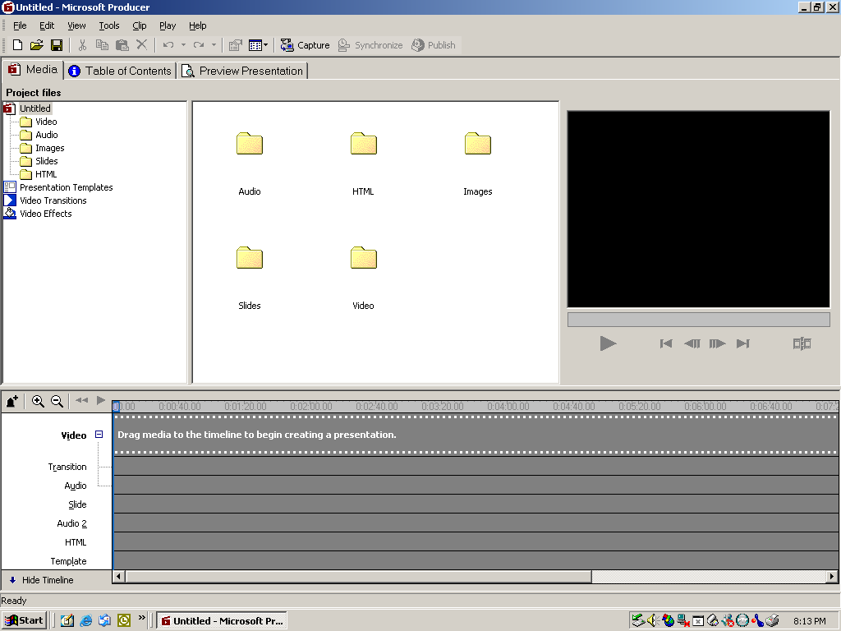

Begin adding your media to the folders:

Double click on the appropriate folder to the left of the screen to enable importing of files:
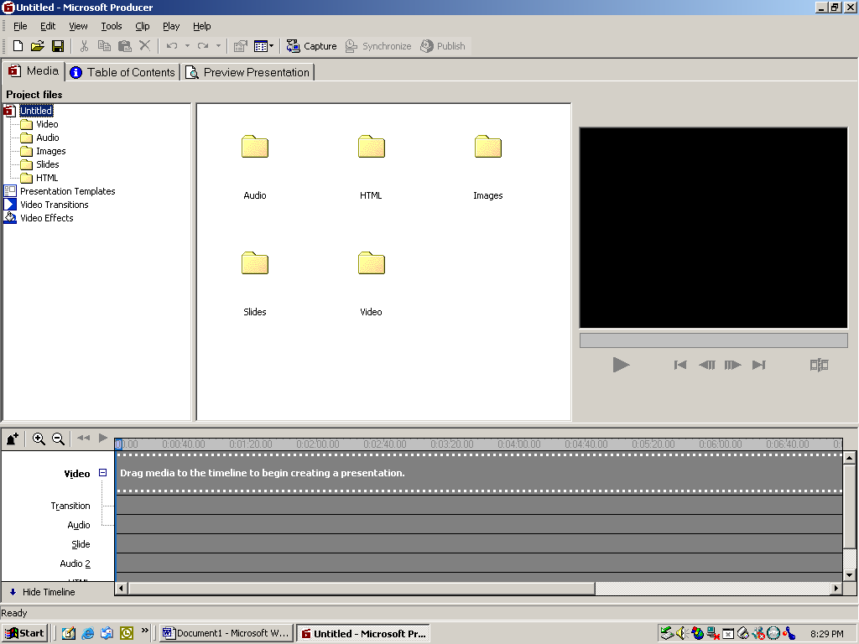

The right side of the screen will look like this:

Double click on the page to insert the image:
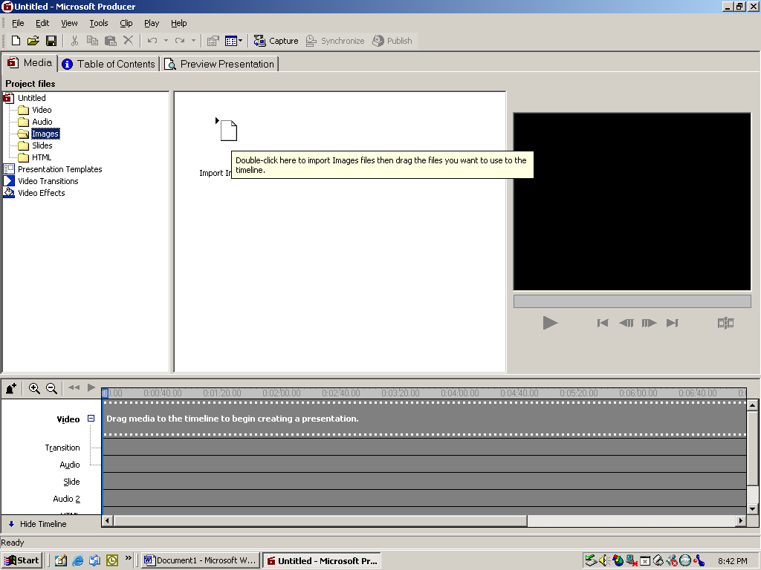

The program wants to know where the image is that you want to put in the project.
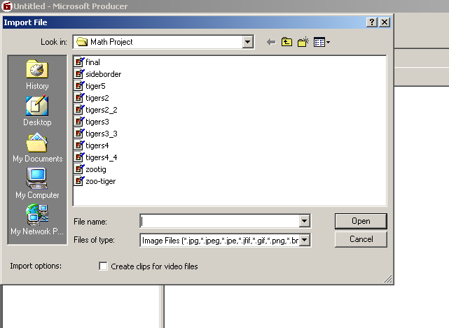

Choose an image and click “open”. The image now appears in the right side of the screen.
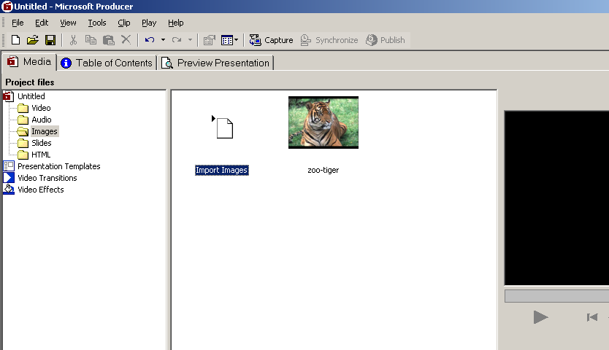

Continue importing your images, audio, video, slides, etc. using this same technique.
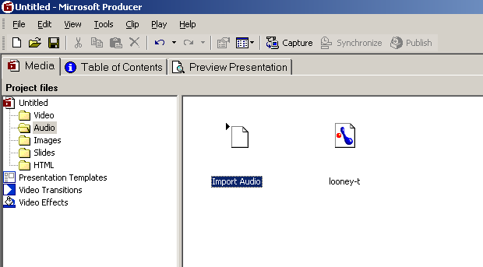

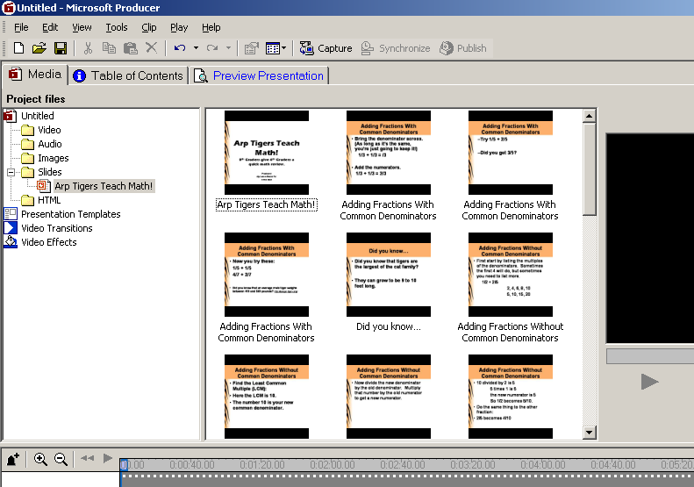

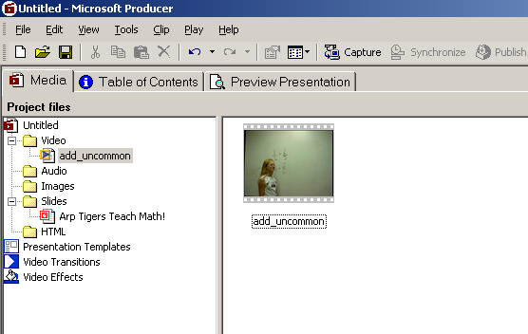

Each type of media will be listed inside its folder on the left side of the screen. Once you have all of the slides, images, video, and audio for your show, you can start adding them to the timeline. This is located at the bottom of the screen.

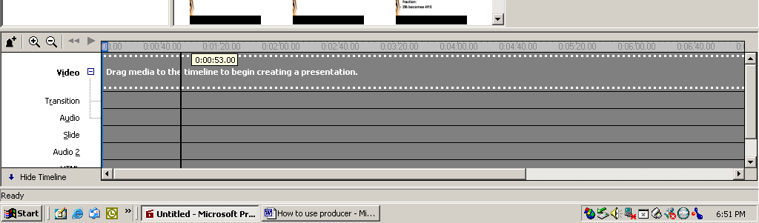

The timeline has a place for all of your types of media. In order to add a piece of media to the timeline, you simply drag and drop.
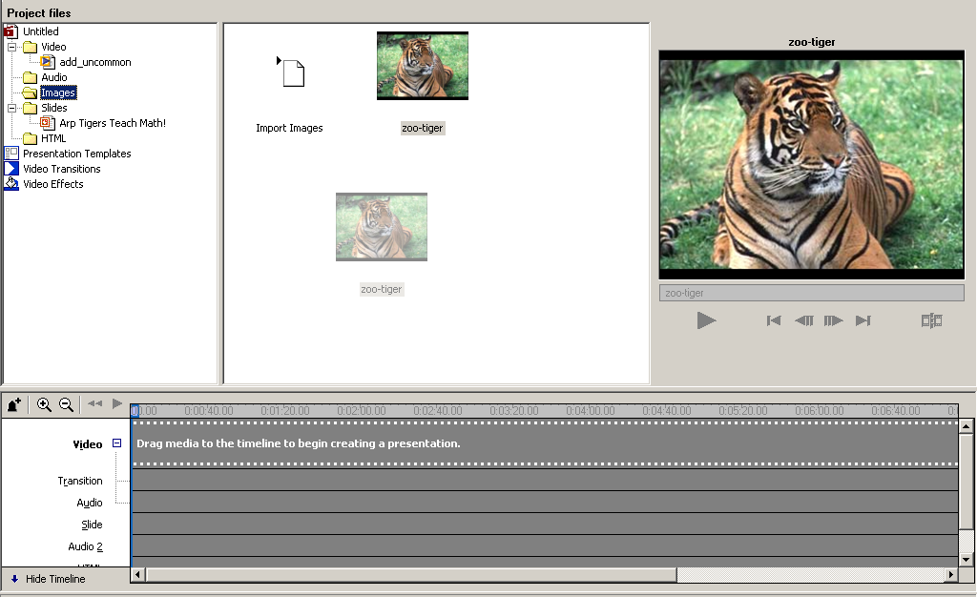

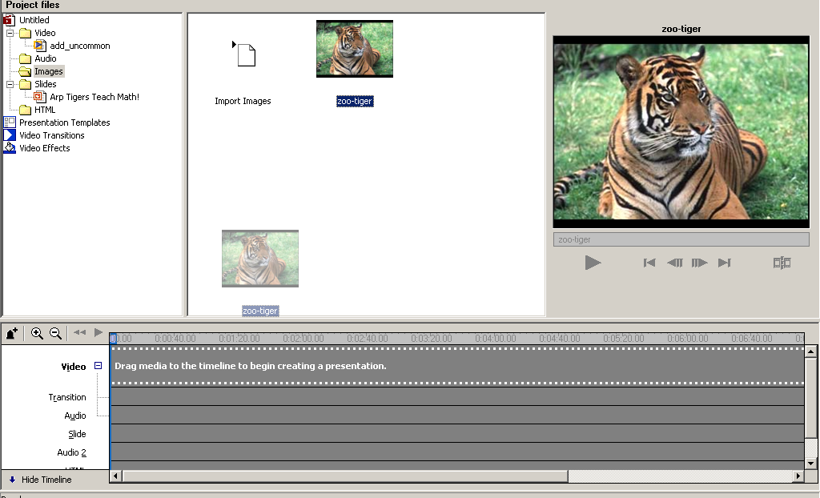

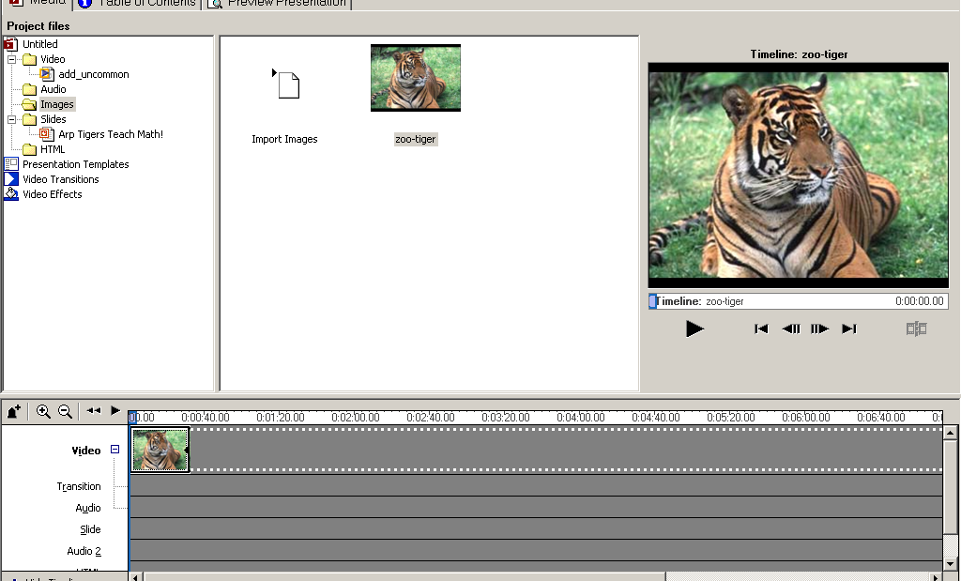

Here the tiger image has been drug to the video media line. This will show the tiger in the video section of the show. We will now add audio, and a slide in the same way.

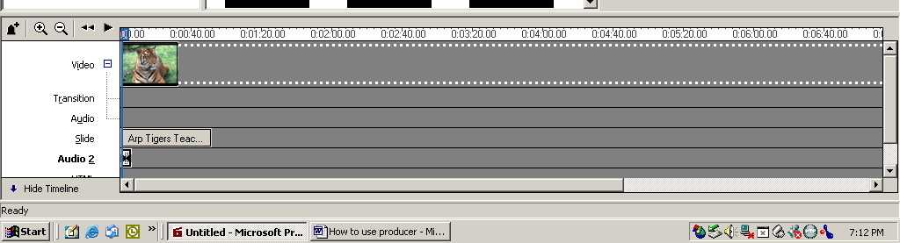

Notice how each type of media occupies a different spot on the timeline. These are, in essence, layered on each other to act as one piece. When the timeline is played, each media will function together. Slides, images, etc. can be stretched to fit your show. You might want a slide to stay on the screen through several images, or you might want one image to be shown through several slides. Just drag the edges of the media so that it lasts for the desired length of time.
As you add video and images, you might like to add transitions between each. This gives your show a more professional look. To do this, simply choose one of the transitions from the “Video Transition” button on the left side of the screen.

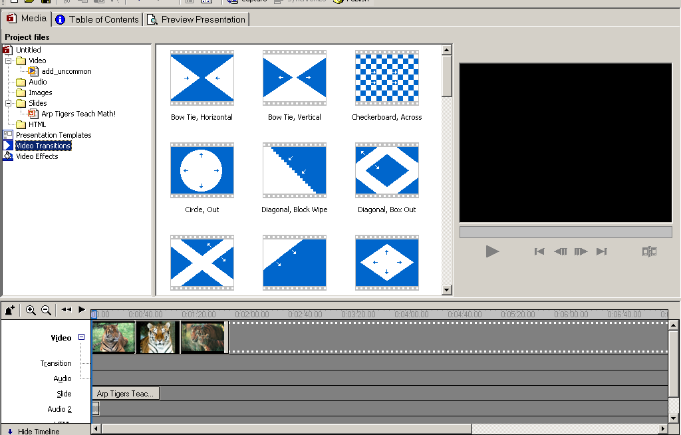

To preview a transition, simply double click the transition. It will appear in the screen on the right and give you an example of the transition.

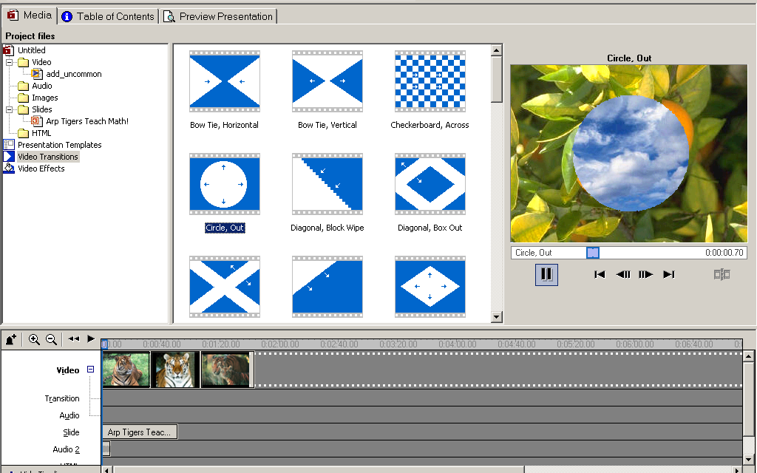

When you find a transition that you like, drag and drop it to the timeline as well.

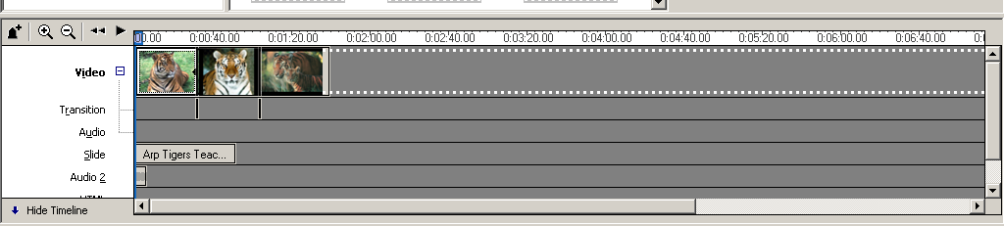

These transitions will appear on the transition section of the timeline. They will be between the images or video.

Now you need to decide how you want your show to be displayed. Click on the “Presentation Templates” button on the left side of the screen. This will display the various ways in which your show may be presented. The video camera represents the part of the show that is composed of images and video images. The slides refer to your power point slides.

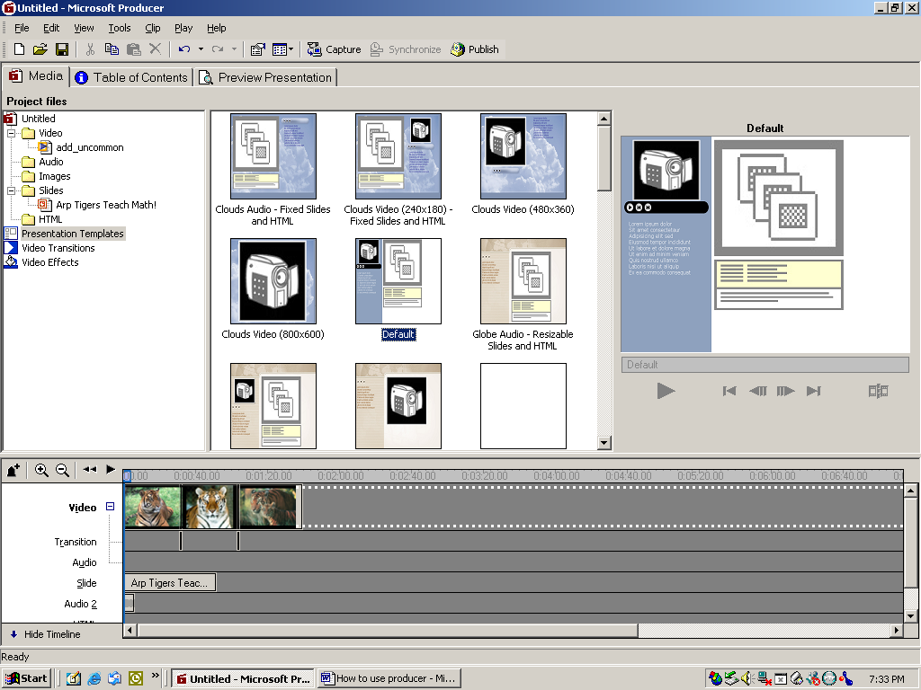

For your first attempt I would suggest you choose the default style. You may modify the colors to suit your own purposes. Double clicking will select this template.

To edit the colors choose “Edit” from the menu bar, and select “Presentation Scheme”

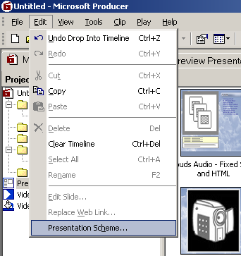

Once you have chosen your colors, you might want to view your presentation to see how it will look in its published form. Click on the tab named “Preview Presentation”.

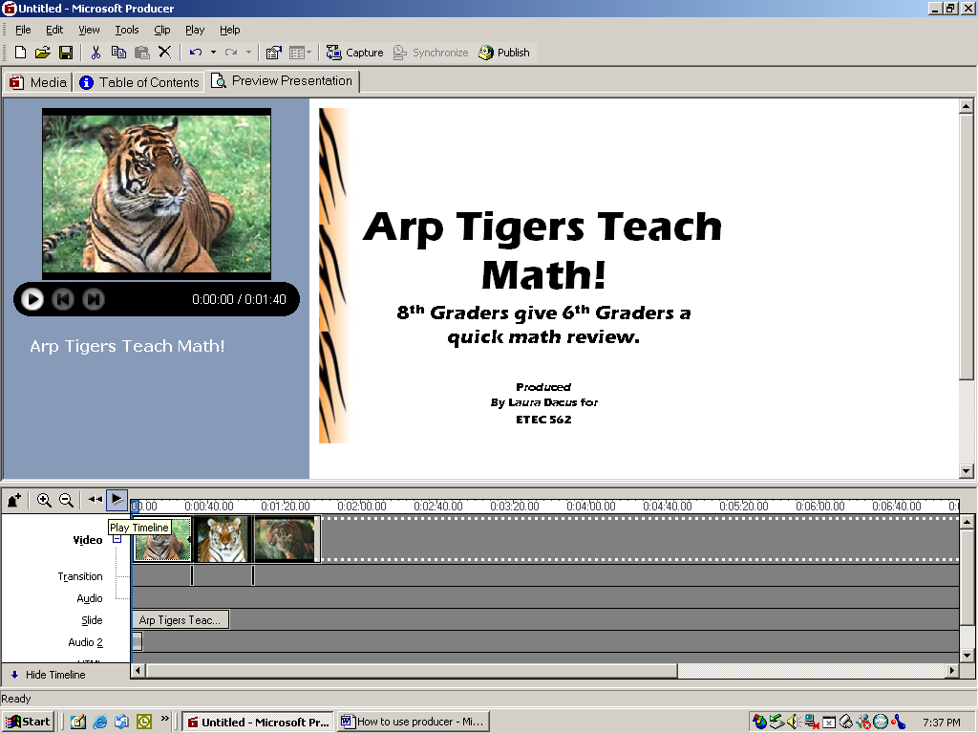

You might also want to hide the Timeline so that you can get the full effect.
Click the “Play” button to view your show.

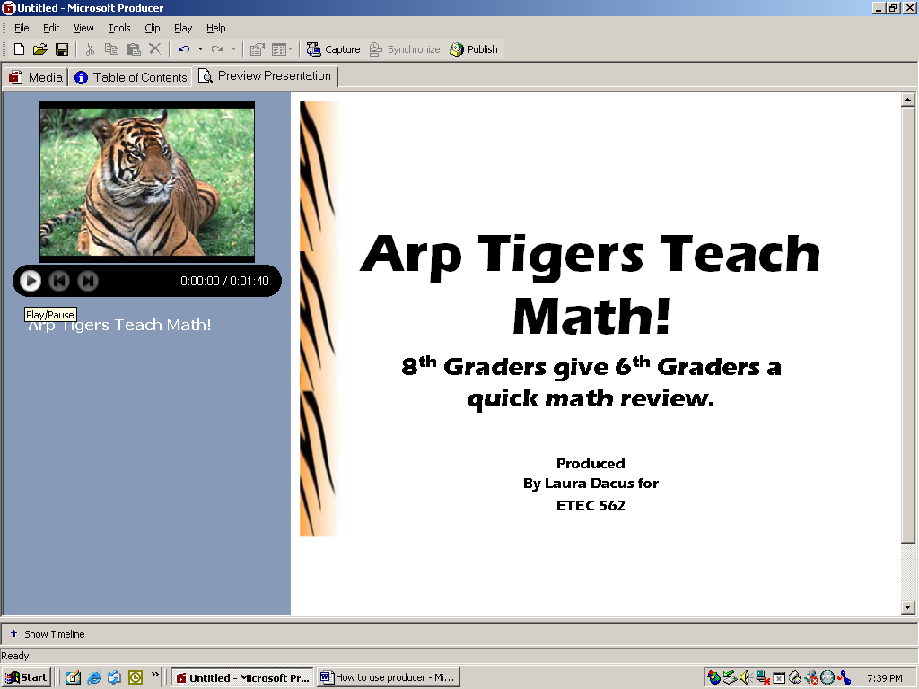

To edit your show, it is easier to go back to the “Media” tab. Editing from this tab slows down the whole process. It is also easier to manipulate the other components in the timeline where you are in the “Media” tab.

Each slide will appear on the “Table of Contents” tab. You can modify this section so that only specific slides or topics are selectable. By that I mean the viewer may choose which slide or section of the show to view.

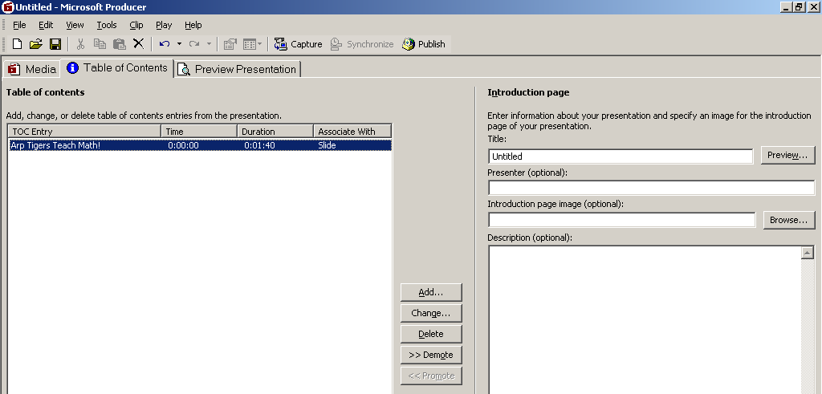

When you have each of the components and the timing like you want, then it is time to publish your show.
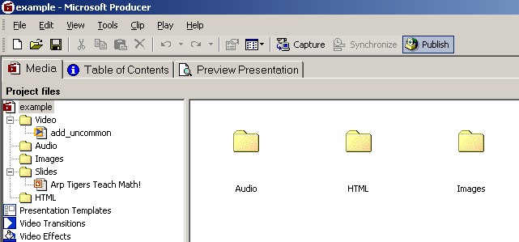

Publishing could take a long time depending on the amount of video in the show.

Now your project is finished!

