Creating an Animation Website Using Dreamweaver
Winston Chim
An Animation website is all about layer and timeline. Layer defines the path where the object is going to move. Timeline provide you with great flexibility for controlling what happens on a page and when it happens.
The following steps will guide you though how to create an animation website with Dreamweaver 4.0:
- Start -> program -> Dreamweaver. You will see a document window.
- Save the document to your folder. (This folder should contain everything you needed to construct your website) Then select insert button from the top of the window; insert a layer.
- Insert an image from file or folder into the layer.
- Click the small box on the right top to select the layer and the image, and then go to the window click Modify, select Timeline, and then select Add Object to Timeline.
- There are a message box and a Timeline window that will pop up. Please click OK in the message box.
- Extend the timeline to fifty. (A timeline is composed of a series of frames. Each frame presents a snapshot of what the object in the timeline looks like at a particular moment.)
- In the Timeline panel, click the end keyframe marker at the rightmost position of the animation bar.
- In the document window, move the layer to the position where you want it displayed when the animation in the document window.
- In the Timeline panel, select Autoplay and Loop. If message box pops up, click OK.
- Press F12 key to preview your page in a browser.
- If you want to create a complex animation path, press the Ctrl key on the keyboard; at the same time move the mouse on the timeline. You will see the mouse becomes a small white point.
- If you left click the mouse, the small white point will become a static point on the timeline. (The layer with the image you inserted before will more accordingly.)
- Move your mouse and point to the right top box of the layer, move the layer to the point where you want it to be that.
- Repeat step 12 and step 13 until you reach the end of the timeline. (An example as follows.)
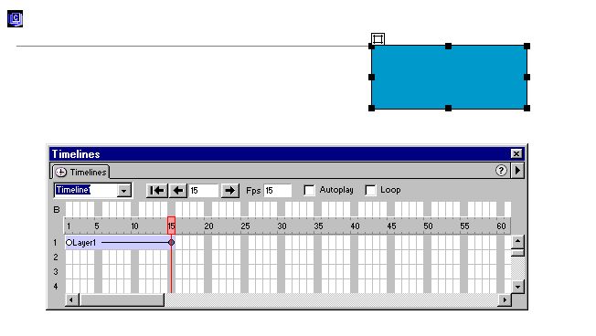

- Press F12 to preview your website.
- Finally, save the website you created into your folder.
Creating an Animation Website (File) Using Fireworks
Winston Chim
The following steps will guide you through how to create an animation website (file):
- Start->program -> firework.
- Choose file->New. You will see a document window. (fireworks call it Canvas)
- Insert an image from file or draw a picture, text or anything you want using the Tools. (You can go to Insert -> New Symbol; and then enter a name for this symbol. Next step is selecting Animation; and then click OK. You will get a new window; and the insert your object.)
- Select the object you created. Put the mouse into the Canvas; left click the mouse.
- Choose Modify -> Animate ->Animate selection.
- Enter the desired setting in the dialog box; and then click OK.
- Choose Window -> Optimize. Select animated GIF.(An example as follows)
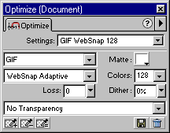
- File ->Export Preview; Options -> Format, Select animated GIF; click OK.
- Press F12 key to preview your animation. (Or go to File-> Preview in Browser.)
- If you want to change the animation setting, go to Modify -> animate ->Setting.
- Repeat step 7 to step 10.
- If want to adjust the number of frames visible before and after the current frame, go to Window -> Fames. In the Frames panel, click the Onion Skinning button.
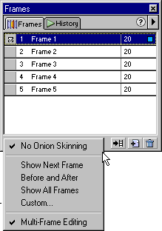
- File->Export; enter the name and select the file type you want to save as.(html or image only.)
Additional Information:
- http://www.macromedia.com/downloads/ allows you download trial version Macromedia products.
- http://www.macromedia.com/devnet/ provides tutorial information.

