Dee Lee Smith
ETEC 562 – Dr. Jason Davis
Texas A&M University-Commerce
November 30, 2005

Steps on How to Create a Podcast . . .

Equipment you need to make a podcast – microphone or headset, computer, audio recording software (free versions available), and a digital audio recorder (optional).

Step 1: Make an outline of what you will say in the podcast.

Step 2: Next, you will need to download a few software programs that are free).
- I recommend Audacity – http://audacity.sourceforge.net/
It’s an open source recording software that’s easy to use.
- Then, install iTunes encoder or another file encoder - www.apple.com/itunes/download or Blaze Media Pro www.blazemp.com

Step 3: Connect your microphone to the microphone-in connection on the PC. Connect headphones to the stereo line out or headphone jack (generally the green audio connection).

Step 4: After you launch Audacity, make sure Microphone is selected as the recording source in the drop-down menu on the mixer toolbar.
Figure 1. Configure Microphone as your recording source
Open the Audacity Preferences window from the File menu. On the Audio I/O tab, verify that your sound card is selected as the device for both playback and recording. In the Channels drop-down box under Recording, choose 1 (Mono). Unless you are using two microphones, the Stereo option simply duplicates the track, making the file size bigger without a resulting improvement to audio fidelity.
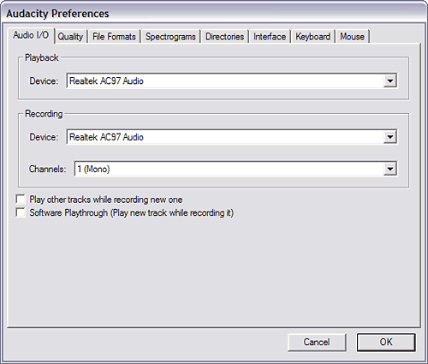
Figure 2. Set the audio recording Channels selection to Mono
Switch to the Quality tab, and choose 44,100 Hz as the Default Sample Rate and 16-bit as the Default Sample Format. Audiophiles will argue that higher sample rates and formats are better, but for spoken word, 44,100 Hz and 16-bit sampling works admirably, especially considering that the resulting output will be MP3. Ignore the rest of the settings on the Quality tab. 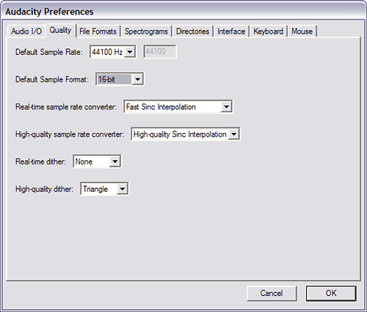
Figure 3. Set the sample rate and bit rate
The File Formats tab configures output options. Choose WAV (Microsoft 16 bit PCM) as the Uncompressed Export Format. Leave the OGG Export Setup untouched. Then, find the location at which you extracted the Lame codec to add it to Audacity by clicking on the Find Library button and browsing to the file location. I generally unzip the Lame codec to C:\LAME so I can find it easily, but there's no "right" location. Once you've added Lame support, close the Audacity Preferences window by clicking on OK.
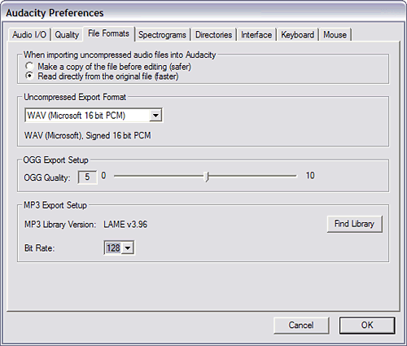
Figure 4. Configure output options

Step 5: Ready to Record
Click on the microphone icon in Audacity's Meter toolbar to turn on monitoring. You should see a red level indicator moving slightly as it picks up ambient room noise. Talk into the microphone and make adjustments to the volume until you get a level that rises close to the right edge of the meter without turning the far-right section solid red. If you get a solid red bar at the far right, the audio is clipping, which means your finished file will sound distorted. Once you've adjusted the level, you're ready to record.
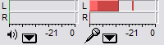
Figure 5. Activate volume-level monitoring
With all the preparations out of the way, it's time to create your first podcast. Push the Record button and start talking.

Step 6: When you finish recording, press the yellow square Stop button and save the file in .wav format. Saving is an important step, in order to make sure you don't accidentally delete the file.
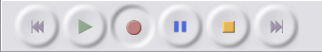
Figure 6. Audacity recording controls
Step 7: Edit the audio file:
It's time to edit the audio file or save it as an MP3 for distribution as your first podcast. Editing can be as simple as eliminating all the places you said "um" by highlighting them and deleting them, or as complex as adding a music bed and inserting other audio clips into the recorded file. To keep this simple, we'll assume you're a one-take wonder and you recited a golden monologue for your first podcast.
To save the file as an MP3, open the preferences again, choose the MP3 bit rate on the File Formats page. (Generally for voice audio, somewhere between 32 and 64 is good enough without making the file size too big.) The resulting audio file gets uploaded to a Web server, and you can link to it in your blog post.
I used Blaze Media Pro to do this, simply because I was more familiar with the program. Therefore, I saved my audio file or .wav file to my laptop and then converted it using Blaze Media Pro to an MP3 file. It’s as simple as converting a .jpg to a .gif or a .doc to a .txt file.
Step 8: Editing ID3 tags
Another important step is editing the ID3 tags for the file. You can easily accomplish this by opening the file in Windows Media Player, iTunes, or one of many other popular music players. In Windows Media Player, right-click on the file in the Now Playing list and choose Advanced Tag Editor. Fill in the Title and Artist fields at the very least, so the proper information about your podcast will display on iPods, Zen Micros, and other portable media players.
Step 9: RSS Feed
You need blogging software with support for enclosures to distribute the file via RSS, like Radio http://radio.userland.com/ from UserLand, which is available for a $40 annual subscription. Movable Type http://www.sixapart.com/movabletype/ is another alternative; it's free for personal use and has support for enclosures if you install a free plugin http://brandon.fuller.name/archives/hacks/mtenclosures/. Several other alternatives also exist. Enclosures are essentially a method to let news aggregation clients like FeedDemon, Newsgator, or Doppler know there's a file attachment associated with an RSS feed entry. Assuming you are using a blogging tool with support for enclosures, you simply type a blog post as you normally would, and use a standard HREF link to the MP3 you uploaded to your server. The blogging software determines that the link should be an enclosure in RSS based on the file type, and it makes an appropriate addition to the RSS feed.
If your blogging tool doesn't support enclosures (Blogger, for instance, currently doesn't), you can generate an free RSS feed with a FeedBurner http://www.feedburner.com/fb/a/home account, which will support enclosures. FeedBurner offers a straightforward wizard to walk you through the process. Once you have the FeedBurner feed created, you promote the link to the FeedBurner feed and encourage people to subscribe.
In each of these cases, the publication process is fairly similar. Upload the MP3 to wherever you have Web space capable of storing files. Make a blog entry just like you normally would, with a title, link, and description. Link to the MP3 in the blog description and post your entry.
If you want to keep your podcast separate from regular blog postings, or if you don't currently have a blog, the simplest way I've found to publish a podcast is to sign up for the $5 account at Liberated Syndication https://www.libsyn.com/index.php?&mode=logout&message= and follow its podcast publishing wizard. The service automatically uploads your MP3 file, and creates the RSS feed and blog post associated with the podcast, all in one easy step. I haven’t tried using Movable Type for my regular podcasting and blogging, but am amazed at the simplicity of using Liberated Syndication.
I hope this information helps you develop wonderful Podcasts and Happy Podcasting!

