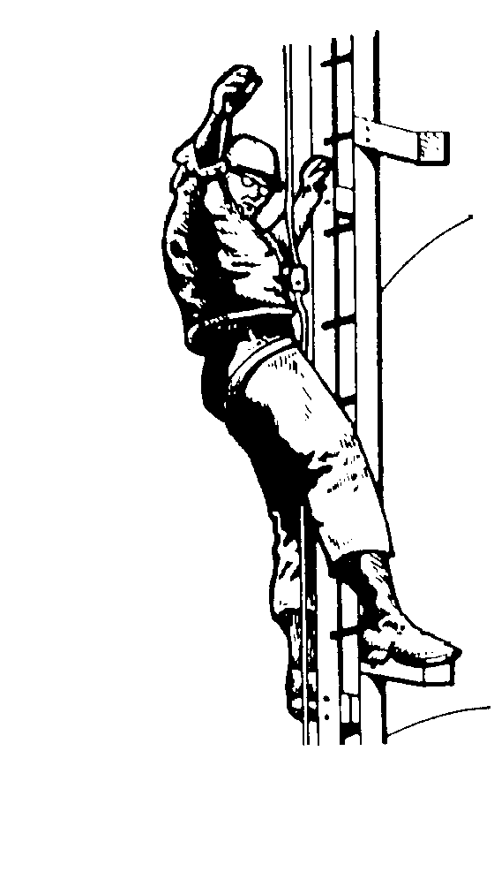 |  | The (Il)literate Lineman  Deconstructing the Literacy Myth through Ethnographic Inquiry
Literacy levels, veiled as skill levels, are influencing the growing segmentation of populations along class and race divisions and therefore require the attention and intervention of educators committed to literacy work.

Michael Pennell (CCC, February 2007)

. . . finding out what students [do] outside class [is] the key to helping them succeed in school.

Beverly J. Moss (Methods and Methodology in Composition Research, 1992)

Terms--
Community of Practice: The starting point for the idea of a community of practice is that people typically come together in groupings to carry out activities in everyday life, in the workplace, and in education. Such groupings can be seen as distinct from the formal structures of these domains. These groups are characterized by three aspects. Firstly, members interact with each other in many ways, which Wenger refers to as mutual engagement. Secondly, they will have a common endeavor, which is referred to as a joint enterprise. Thirdly, they develop a shared repertoire of common resources of language, styles, and routines by means of which they express their identities as members of the group. Situated learning then means engagement in a community of practice, and participation in communities of practice becomes the fundamental process of learning. (Barton and Tusting 1-2, emphasis in original)

Rhetorical Dexterity: An approach that attempts to develop in students the ability to effectively read, understand, manipulate, and negotiate the cultural and linguistic codes of a new community of practice based on a relatively accurate assessment of another, more familiar one. (Carter, The Way Literacy Lives 22)

Materials--
English 100 materials available online at http://faculty.tamu-commerce.edu/scarter/bwp_introduction.html
Required reading: “What is a Community of Practice?” (Carter, url below); excerpts from Steven Johnson’s Everything Bad is Good for You (2005), James Paul Gee’s What Video Games Have to Teach Us About Literacy and Learning (2004), and David Russell’s “Activity Theory and General Writing Instruction” (1995); Mike Rose’s The Mind at Work: Valuing the Intelligence of the American Worker (2005)

English 102 materials available online at http://faculty.tamu-commerce.edu/scarter/102_resources.htm
Required reading: Literacies in Context (Carter, 2007); FieldWorking (Sunstein and Chiseri-Strater, 2006)

Justification for Current FYC/BW Approach—
By focusing on literacy as both an object of scholarly inquiry and the product reproduced through scholarly inquiry, we approach first-year composition as “a course about how to understand and think about writing in school and society” (Downs and Wardle 9). By focusing on literacies as they exist in context, and asking students to contribute to this scholarly conversation, we attempt to teach beginning college writers “the ways writing works in the world and how the ‘tool’ of writing is used to mediate various activities” (9). More importantly, an approach like this frames the first-year composition course as a place where writers create real, meaningful and usable knowledge. Knowledge that changes how we think about literacy and literacy acquisition and that should, therefore, change how we go about teaching it. Knowledge that continues to change me and what it means to teach writing.

References

Brandt, Deborah. “Accumulating Literacy: Writing and Learning to Write in the Twentieth Century.” College English. 57 (1995): 649-668.

Carter, Shannon. “Living inside the Bible (Belt): A Critical Approach to Conservative, Evangelical Literacies.” College English (July 2007): in press. .

---. Literacies in Context. Southlake, Texas: Fountainhead Press, 2007.

---. “Redefining Literacy as a Social Practice.” Journal of Basic Writing. Forthcoming.

---. The Way Literacy Lives: Rhetorical Dexterity and the “Basic” Writer. Albany, NY: State University of New York Press, in press.

---. “What is a Community of Practice?” <http://faculty.tamu-commerce.edu/scarter/CofP.htm>. November 30, 2006.

Downs, Doug and Elizabeth Wardle. “Teaching About Writing, Righting Misconceptions: (Re)Envisioning FYC as Introduction to Writing Studies.” CCC, forthcoming.

Fingeret, Arlene. "Social Network: A New Perspective on Independence and Illiterate Adults." Adult Education Quarterly 33.3 (1983): 133.

Freire, Paulo. Pedagogy of the Oppressed. NY: Penguin Books, 1972.

Gee, James Paul. Situated Language and Learning: A Critique of Traditional Schooling. NY: Routledge, 2004.

---. What Video Games Have to Teach Us About Literacy and Learning. Palgrave, 2003.

Giroux, Henry.. Theory and Resistance: A Pedagogy for Opposition. South Hadley, MA: J.F. Bergin Pub, 1983.

Graff, Harvey. The Literacy Myth: Cultural Integration and Social Structure in the Nineteenth Century. Academic Press, 1979.

Hull, Glenda and Katherine Schultz, Eds. Schools Out!: Bridging Out-of-School Literacies with Classroom Practices. NY: Teachers College P, 2002.

Johnson, Steven Everything Bad is Good for You: How Today's Popular Culture Is Actually Making Us Smarter. Riverhead Hardcover, 2005.

Lave, Jean and Etienne Wenger. Situated Learning: Legitimate Peripheral Participation. Cambridge UP, 1991.

Merrifield, Juliet, Mary Beth Bingman, David Hemphill, and Kathleen P. Bennett deMarrais. Life At The Margins: Literacy, Language, and Technology in Everyday Life. Teacher’s College P, 1997.

Moss, Beverly J. “Ethnography and Composition: Studying Language at Home.” Methods and Methodology in Composition Research. Gesa Kirsch and Patracia A. Sullivan, Eds. Carbondale: Southern Illinois UP, 1992. 153-71.

Pennell, Michael. “’If Knowledge Is Power, You’re About to Become Very Powerful’: Literacy and Labor Market Intermediaries in Postindustrial America.” CCC. 58.1 (February 2007): 345-384.

Resnick, Lauren B. “Literacy In School and Out.” What Counts as Literacy: Challenging the School Standard. M.A. Gallego & S. Hollingsworth, Eds. NY: Teachers College P, 2000. 27-41. Available Online: <http://pickle.ed.psu/moodle/file.php/33/literacy/resnick.pdf>. 15 September 2005.

Robillard, Amy. “Young Scholars Affecting Composition: A Challenge to Disciplinary Citation Practices” in College English 68 (2006): 253-70.

Rose, Mike. The Mind at Work: Valuing the Intelligence of the American Worker. NY: Penguin, 2005.

Russell, David R. "Activity Theory and General Writing Instruction." Reconceiving Writing, Rethinking Writing Instruction. Joseph Petraglia, ed. Mahwah, NJ: Lawrence Erlbaum, 1995. 51-77.

Saxe, Geoffrey. Culture and Cognitive Development: Studies in Mathematical Understanding. Hillsdale, NJ: Lawrence Erlbaum Associates, Inc. 1991.

Schribner, Sylvia and Michael Cole. The Psychology of Literacy. Cambridge, MA: Harvard UP, 1981.

Street, Brian V. Social Literacies: Critical Approaches to Literacy in Development, Ethnography, and Education. NY: Longman, 1995.

Yancey, Kathleen Blake. Delivering Composition: The Fifth Canon. Portsmouth, NH: Boynton/Cook, 2006.

---Reflection in the Writing Classroom. Utah State UP, 1998.

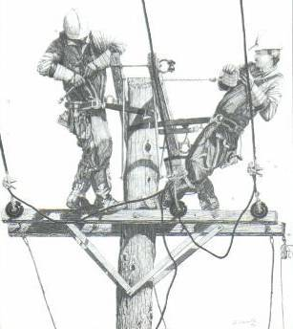

Young Scholars in Writing: Undergraduate Research in Writing and Rhetoric publishes research articles written by undergraduates on topics related to rhetoric and writing. Generally, we value papers that integrate secondary sources from the area under investigation, offer primary research conducted by the writer(s), and/or ground inquiry in a defined theoretical framework. All in all, we publish articles that make an intellectual contribution to their respective fields. Young Scholars in Writing welcomes collaborative manuscripts.

View previous issues and submission guidelines online: http://www.bk.psu.edu/Academics/Degrees/26832.htm

Presentation available online at http://faculty.tamu-commerce.edu/scarter/FRS2007.htm
Shannon Carter
Texas A&M-Commerce
Shannon_Carter@tamu-commerce.edu
http://faculty.tamu-commerce.edu/scarter/

Stephen Williams
Texas A&M-Commerce
swilliams19@leo.tamu-commerce.edu

The concept communities of practice developed by Jean Lave and Etienne Wenger (Lave and Wenger 1991, Wenger 1998) as a central idea in situated approaches to learning has been taken up across social, educational, and managerial sciences. It has been used, applied, criticized, adapted, and developed by a wide range of researchers in these fields. It is certainly one of the most articulated and developed concepts within broad social theories of learning. (Barton and Tusting 1)

