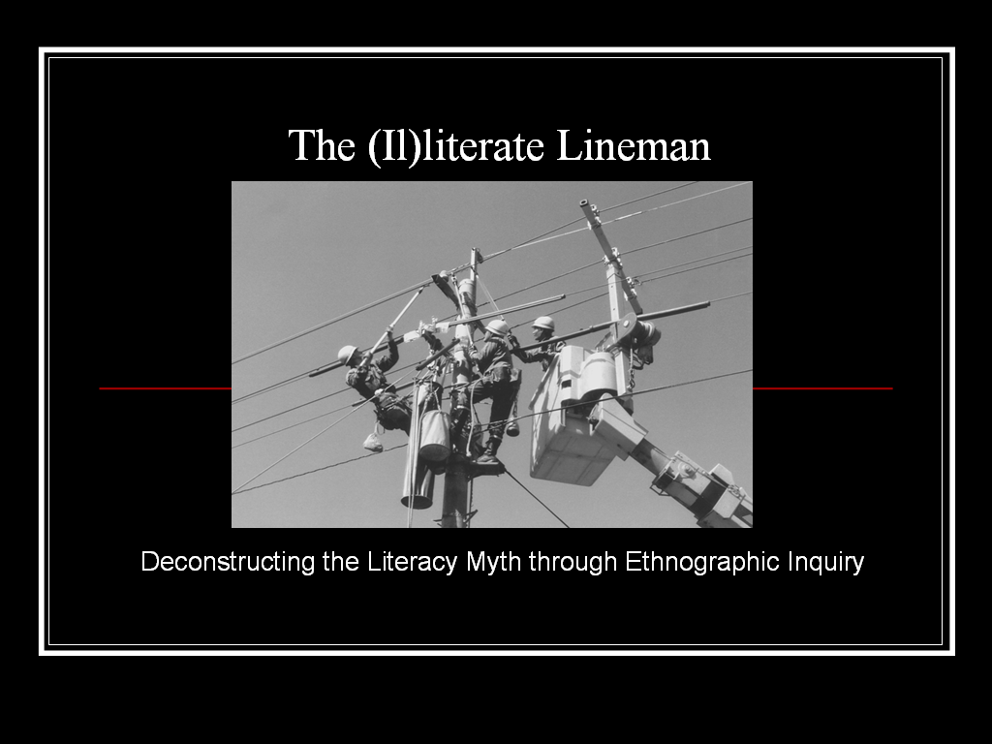

Apparently America is in the throes of yet another “literacy crisis”—a crisis that occurs with such great regularly that some have dubbed it “always new.” According to the hype regarding the general public’s reading and writing abilities, college graduates “can’t spell” or write an email without “endless grammatical problems,” high school graduates can’t locate Iraq on a map or recite, with any accuracy, a single Amendment to the US Constitution, and “no one reads anymore.”
What these arguments regularly ignore, however, are the sophisticated and flexible literacy practices in which these same “illiterates” likely engage on a daily basis. They text-message one another for hours on end, generate complex profiles on MySpace and engage in online discussions about the war in Iraq; they look up user reports before purchasing big ticket items and devise sophisticated systems for hiding and tracking items--in community--through the use of GPS systems (something I’m told is called geocaching).
They research and write, read and think, negotiate complex charts and maps. In fact with the incredible upsurge in everyday literacy practices these last several years, it appears we are experiencing not a literacy crisis but, in fact, literacy prosperity. Literate activities are everywhere these days; perhaps even more so than ever before. As for the demise of more traditional versions of literacy like reading a novel or skimming a newspaper, research tells us that even that is on the upswing.
Still, the myth of the literacy crisis persists, fueled by narrow definitions of literacy perpetuated in our schools and public policies. When conceptualized loosely as the ability to read and write, literacy becomes a fundamental prerequisite for individual progress, and, once acquired, the skills making up this “ability to read and write,” exist entirely within the heads of individuals. According to this skills-based definition of literacy, when one is considered literate in one context, she can expect those skills to serve her equally well in all other contexts. Such definitions represent literacy as a set of stable, portable, neutral skills that enable the user to encode and decode texts “correctly,” regardless of the type of text, the conditions under which the text is encoded/decoded, the purpose of the text, the people surrounding the text, the place in which the text is situated, or the lived experiences of the readers/writers who put the text to use.
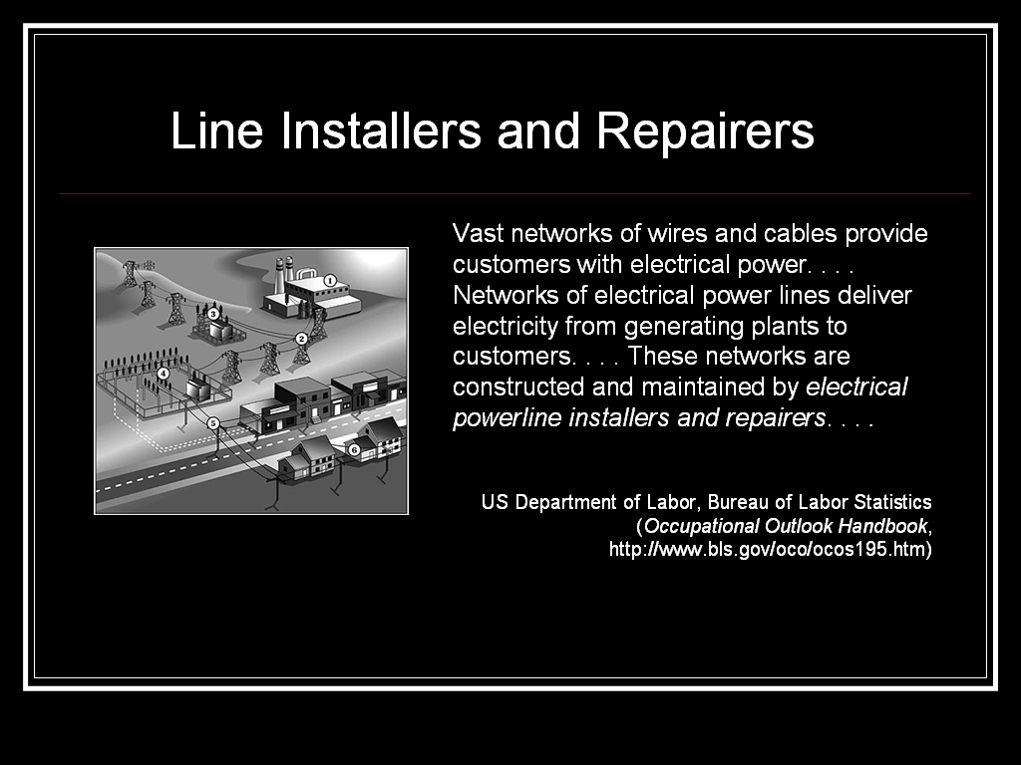
The purpose of the current presentation is to deconstruct this static, artificial literacy model by illustrating the ways in which literacy manifests itself in a particular context: the spaces associated with electrical line repair and installation. That we choose to articulate the shape and function of literate activity in a blue collar position is significant, albeit counterintuitive. In the first place, Stephen—my co-presenter and a current student in our First-Year Composition program—is highly literate in this community of practice. For several years before returning to school, Stephen worked as an apprentice lineman (“lineman” being a term used by members of this community of practice and uncontested by Stephen’s former co-workers, who were always all men).
In the second place, blue collar work is often considered to be manual labor far removed from the college classroom, not the kind of “mindwork” accepted by most as the immediate and primary function of higher education. Contrary to popular belief, however, manual and service labor requires much of the mind—requirements very similar—in fact if not in kind—to the requirements of more typically “academic” or “intellectual” pursuits. In The Mind at Work: Valuing the Intelligence of the American Worker, Mike Rose challenges what he calls our “biases about intelligence” when it comes to manual labor (like plumbing and carpentry) and service work (like waiting tables and styling hair). As he explains, when we dismiss the intelligence necessary to install a new toilet in an older home, color hair without drying it out, or effectively serve a restaurant full of hungry customers, we “develop limited educational programs and fail to make fresh and meaningful connections among disparate kinds of skill and knowledge” (216). In other words, negotiating any complex community of practice--from video games to electrical work, from the Air Force to the basic writing composition classroom--demands a deep awareness of the internal structure and connections among the social network that makes up the target activity systems within that community.
As we will learn from the preliminary findings of Stephen’s case study, the ability to encode and decode print is not enough to make one literate in the community of practice that is electrical line installation and repair. Even more interesting perhaps: neither does a total inability to encode/decode alphabetic, print-based texts make a worker illiterate.

The Work
Electrical line installation and repair is complex, requiring of workers an extensive knowledge of the vast networks of lines and cables that carry electricity from the generating plants to the customers, the means by which this electricity is carried, and effective methods for intercepting this power to connect it to new customers and/or repair existing lines without getting killed in the process.
SW: The job detail is subject to change from day to day, and hour to hour. The day may start off with building three spans of overhead primary line, hanging a transformer, then running service to a home. All before lunch. After lunch, a storm is brewing on the west side of the system: “lights out.” Now the work is storm damage [control and repair rather than installation]. Working “lights out” or “storm damage” is required until the lights in the entire system are back on. Lightening is the cause of the majority of storm damage based “lights out.”
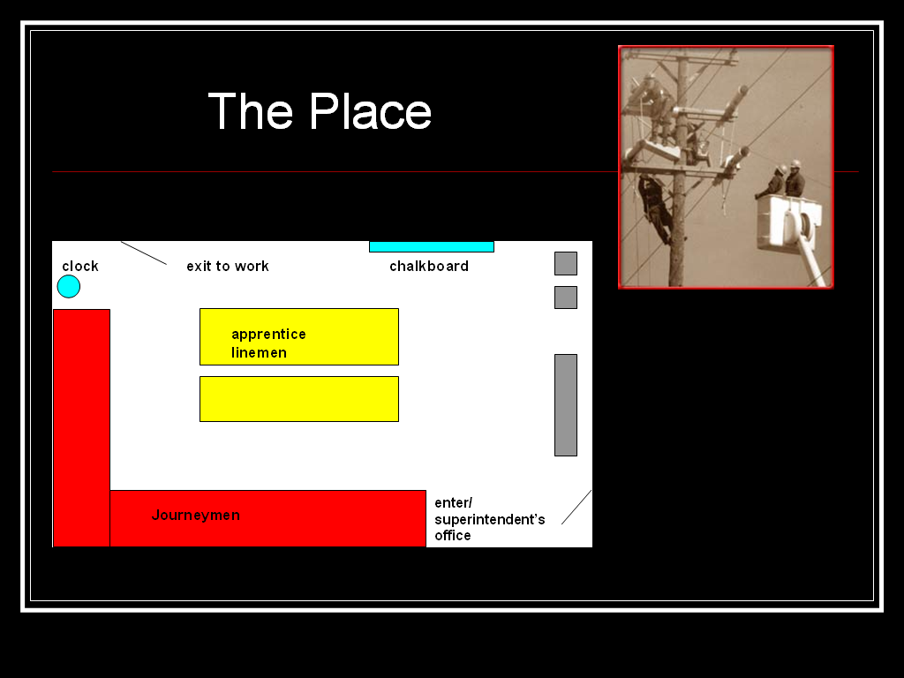
The Place
Texts mediate just about every aspect of a lineman’s workday, beginning at 7:00 a.m. in the linemen’s room where they gather to complete the extensive paperwork required “to charge out the accounts” associated with the work completed the day before and receive from the line supervisor the “job order sheets” that detail the new day’s work assignments.
SW: Most of the [paper]work is done for the office personal to charge out the accounts. Each job and employee has a different account that the money has to be taken out of. Government funding is a major reason for the detailed paperwork. For example, the new trainees had one code that they had to use on their time sheets. The veteran lineman would have another. And each job done by the lineman had a separate account. An example would be: treetrimmers would put one account number on the time sheet for what work they did that day. If they moved locations in the middle of the day, they may have to change the account number for the second half of their day.
SC: Thus, the “time sheets” required of workers an ability to translate the work they did the day before into the various codes representing their employment status (apprentice lineman or journeyman), the job itself (trimming trees, new line construction, etc), and the job’s location.
The other key text mediating the lineman’s work is the “job order ticket,” which is the print-based text that articulates the day’s work. By about 8:00, after most of the timesheets are complete, the journeymen pick up the job order ticket created by the line superintendent. Most journeymen then pass the text along to the apprentice lineman with whom they are paired. The apprentice then cleans the truck and loads it with the tools and equipment appropriate for the jobs detailed on the job order ticket. By 9:00, they are out the door, beginning the next literacy event (again mediated by the job order ticket): the “tailboard discussion.” As I understand it, the “tailboard discussion” entails the reading and implementation of the instructions detailed on the job order ticket. The literacy event is the series of conversations, interpretative acts, and translations that take the one-page job order ticket into the field: Where is the job located? What does the job require us to DO? How can we make that happen safely, effectively, and in a timely manner? It is the job of the journeyman to make these decisions and thus guide his crew in translating into practice the print-based text that is the job order ticket.
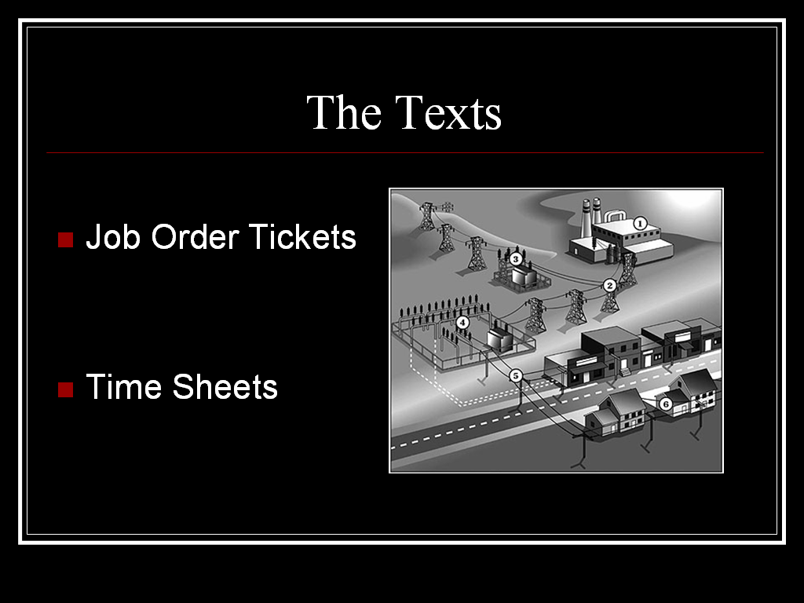
Given that so much of the lineman’s work depends on his ability to successfully interpret the “job order ticket” and translate the job completed into the requisite codes via the “timesheets” recorded by the workers in the field and circulated, tabulated, and filed by the “office workers,” it seems important that all lineman possess the ability to encode and decode print in the traditional sense. However, this may not always be the case.
In his final paper for a basic writing course last fall (2006), Stephen introduced me to Johnny, a “journey lineman [who] ran a bucket truck.” As Stephen explains, “[Johnny] was ‘the Man’ when it came to doing energized line work. He was also the man [who] was to teach us ‘grunts’ how to be lineman” (1). A whiz with mathematics--a particularly valuable trait given the fact that, according to Stephen, “Electricity is nothing but numbers”--Johnny advanced through the ranks rather quickly and, by the time Stephen met him, this trait and his twenty years experience in the field had made Johnny the “best lineman that they had”—and the most highly paid.
But while he was, as Stephen puts it, “by far, the most literate lineman the company had” (Williams 5), Johnny could neither read nor write--at least not in the traditional sense of encoding and decoding print-based texts. Instead he relied on the collaborative reading and writing strategies that literacy scholars have found—time and again—to be a regular part of literacy as practiced in the “real” world. As Arlene Fingeret reveals in her 1983 study "Social Network: a New Perspective on Independence and Illiterate Adults":
People do not need to identify literacy “problems” in order to get a friend to help understand a tax form or to have the railway official write out some train times. We all do this and there are particular people used for support who we can regard as brokers for literacy activities. It may be a neighbour or a friend who deals with figures or fills in the forms. It may be institutionalised, the railway officials who look up train times, the travel agents who fill in holiday forms for customers. (qtd. in Barton 202)
These are exactly the kinds of strategies Stephen tells me his former co-worker has been relying on for all of his working life. Johnny used his traditionally-literate co-workers like Stephen as brokers for the print-based literacy activities his job required him to complete, just as they often relied on Johnny’s extensive literacies in electrical line repair to get the job done. As Johnny explained it to Stephen one day when he asked him how he was able to make sense of the job order sheet when he couldn’t read a word of it, “That’s what I have you for!”
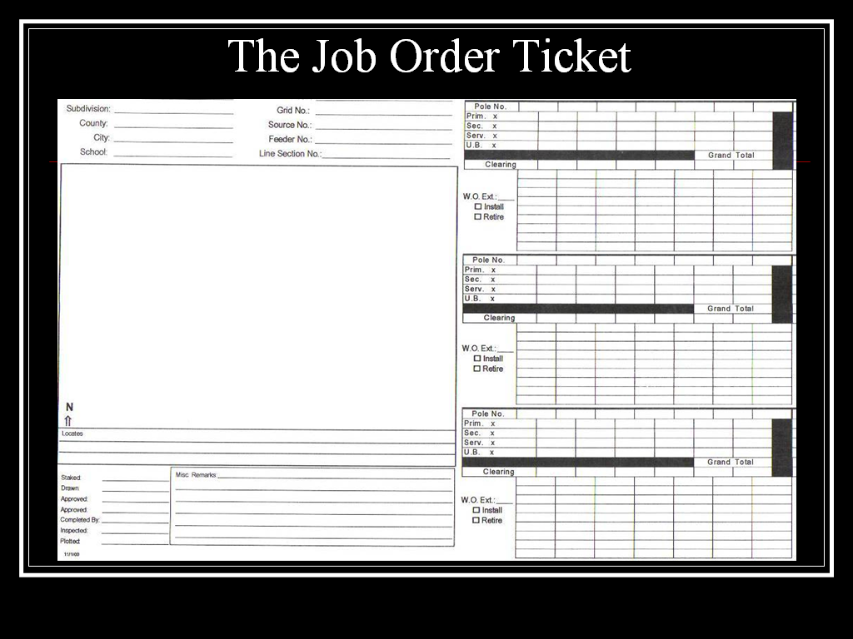
The Job Order Ticket and Johnny’s “Collaborative” Reading Strategy
SW: The “job order ticket” is a very detailed set of instructions for a specific job [out in the field, developed by the line supervisors and engineers that script the project details]. Prior to arrival on the job site, Johnny would pass the job order ticket to me (or whoever was working with him) in order to decode the written text. After the printed text had been decoded for him, he would then take the job order ticket back and, by looking at the sketch given [(see upper, left-hand corner of the current slide) and drawing on his extensive knowledge-base and experience in electrical line work], begin to explain the job in detail.
SC: One strategy Johnny relied on to “read” the job was his talent with numbers. As Stephen explains, “Johnny was quite a ‘number’s guy.”
SW: When a job order ticket is entered into the system, it has to have a specific location. This location is given in a grid number [that corresponds to the map used by all lineman], . . . a set of numbers that reads [in this example], 33-32-5-65-71. Let me define this number for you now. The first number is the source number. It has nothing to do with the map location itself but rather [the power source for that area]. The next two sets of numbers (32-5) [indicate] the area location. [For instance, 32-5 is between Rockwall and Quinlan, as represented on the FEC-produced map over about 10 pages]. The last number [represents the “section,” which basically narrows the location down still further as one “section” is equal to one square mile]. The last number [i]s the block number.
Johnny knew the grid system well. Nine times out of ten, he could get you to the job without even getting the map out.
SC: The rest of the job order ticket proved to be a greater challenge, with all the remaining job details represented in the traditional alphabetic code. Even more problematic was the fact that as a journeyman and senior employee Johnny was largely responsible for the line crew, many of whom were newbies and all of whom depended on Johnny for leadership and guidance in completing the job detailed on the job order ticket. As described above, this literacy event is called the “tailboard discussion”—the point at which the journey lineman arrives at the job site and informs the line crew there about the job to be done and how to do it. In order to lead this tailboard discussion, Johnny absolutely had to read and understand the job order ticket. On the way to the job, Johnny would pass the job order ticket to the apprentice sitting in the truck next to him, which the apprentice would then “read” to Johnny but often not understand. As a highly literate lineman, Johnny easily understood the meaning of the words, codes, and special terminology decoded by the apprentice who was often lacking the experience and knowledge necessary to comprehend much of what he read aloud to Johnny.
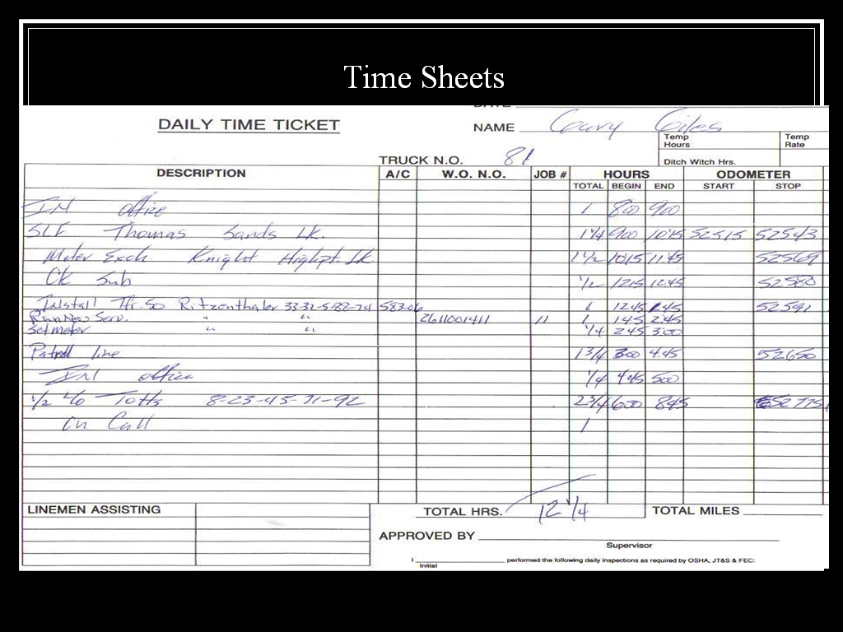
THE TIMESHEETS
STEPHEN: It seems that the most difficult task for Johnny came at the end of each job. This would be the “timesheet.” The “timesheet,” [as we’ve explained], is the detailed description of the work performed by the lineman and his help for that day. [To complete this print-based task], Johnny would do some sort of note-taking that only he could decode. That night, his wife would help him complete the timesheets (before returning to work the next day) [by translating Johnny’s “notes” into the traditional alphabetic and company-specific codes his employers and the office staff could recognize.] This would explain to me why he was always the first lineman out of the office each morning. The work done in the lineman’s room each morning was the biggest obstacle that Johnny faced each day, [but] Johnny had no problem with doing homework.
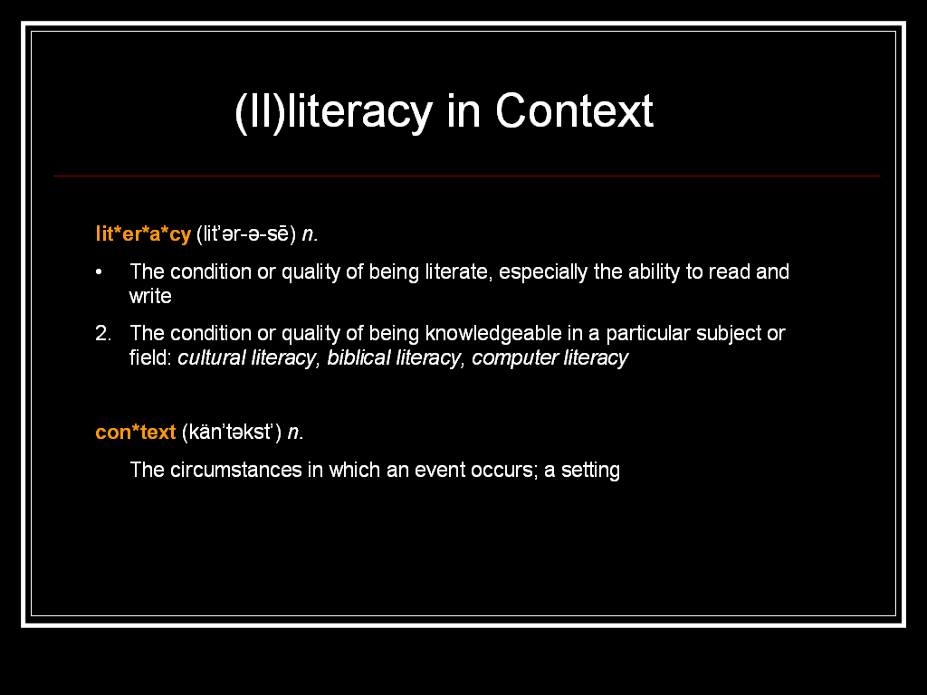
Illiteracies in Context
Johnny’s story of literacy-in-collaboration (with his co-workers, with his wife) is not at all uncommon. In fact, as research into out-of-school literacies have proven time and again, neither “the condition or quality of being literate” nor “the ability to read and write” exist apart from the contexts in which literate action is put to use. Literacy itself as it is practiced in a variety of contexts takes its form from its function, not the other way around. In Brazil, for example, 10 to 12 year old, candy vendors with little or, for the most part, no formal education have devised rather complex mathematical systems for determining appropriate purchase costs from wholesalers and sale prices likely to offer adequate profit for the vendor while remaining competitive enough among other venders to continue to attract new customers—and all of this within an infrastructure of wildly fluctuating inflation rates (see Saxe). Miles away and several years earlier, Sylvia Scribner and Michael Cole’s study of the Vai population in Liberia proved that “there is not one literacy but many literacies, each acquired as a functional adaptation to a particular social need” (William 48). In America in the 1990s, Juliet Merrifield’s profiles of 12 diverse individuals shows us how people with “limited literacy skills” are able to negotiate a largely print-based society in many of the ways alarmist literature about the literacy crisis tell us they cannot—they hold jobs, pay taxes, value education, and support their school-age children in their efforts to “improve” themselves
And despite the fact that everyone in this room would be judged as highly literate according to traditional measures of “the ability to read and write,” it seems unlikely that those of us—like me—without previous access to this kind of work could read or write the texts that mediate the daily activities of the electrical line worker—at least not with ease and without help.
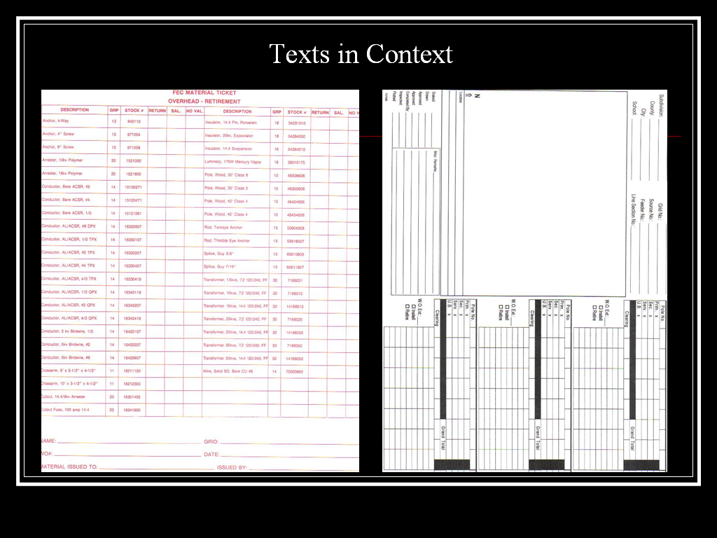
Doing so requires of users—among other things--an understanding of the coding system developed and reproduced in that particular office for accounting and recordkeeping purposes, an awareness of the daily job flow and the various hands through which the texts generated and consumed must pass (and why and when). Like just about any text, these texts are put to use within a very specific community of practice with very specific goals and methods for achieving these goals. That means “reading” and “writing” the texts required of electrical line workers demands of users a deep awareness of the work that is electrical line installation and repair (the profession) and the specific value sets, special terminology, and other actions reproduced within the specific company in which this reading and writing takes place. It also requires a great deal of math. As Stephen explained it to me in his final paper last fall, “There are many, many . . . mathematical formulas used in the field of electricity” and thus required of literate lineman: “Trigonometry is used to figure the phase angle of wye and delta transformers. Algebra is used to figure the turns ratio in a transformer” (Williams 4).
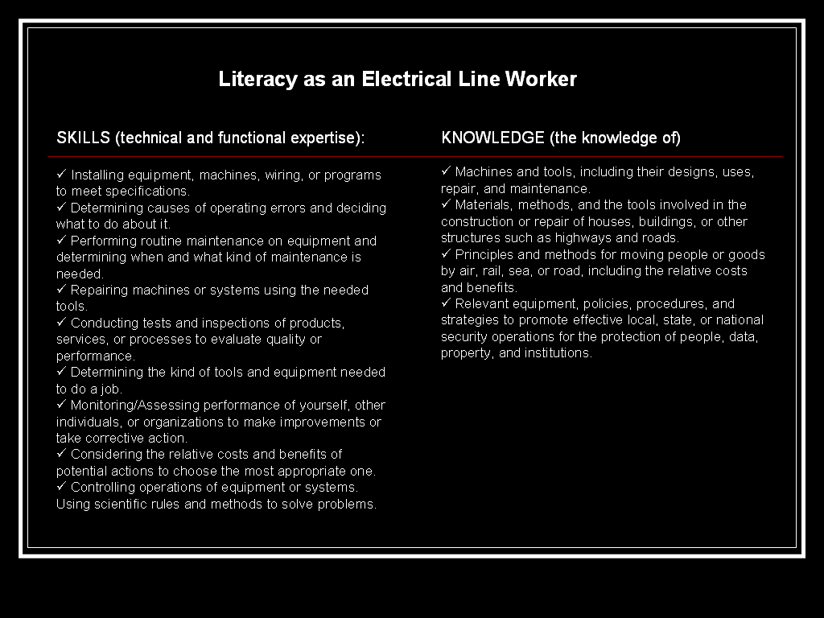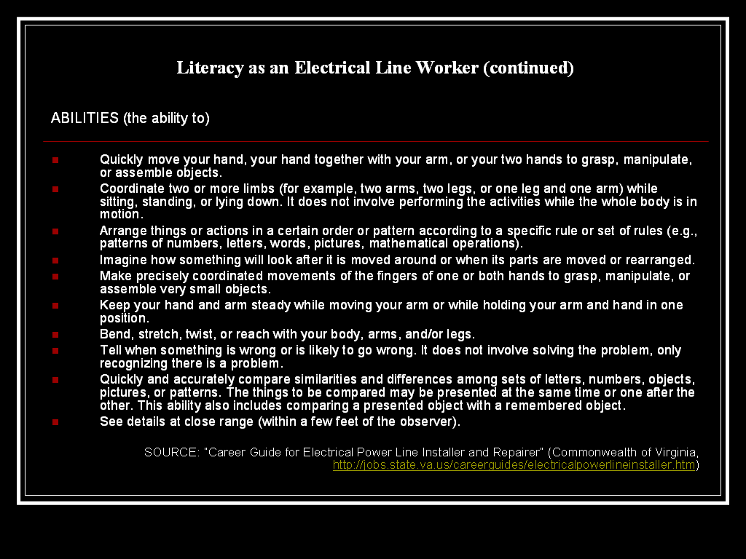
Like many jobs, the specific technical expertise, knowledge, and abilities required of line workers are complex, content- and context-specific, and multifaceted. Given our own abilities to encode and decode texts in a variety of contexts, the people sitting in this room—again all highly educated and well read—could likely begin to make sense of the forms associated with this kind of work when in collaboration with someone else who had the knowledge, technical expertise, training, and experience to help us understand what the words we can decode actually mean when put to use in the workspaces for which and in which these texts are to be written and read. But without the help of a “literate lineman” (like Johnny or Stephen here), our struggles with the texts associated with this kind of work would likely mark us as “illiterate” in this community of practice.
In other words, as Glenda Hull puts it, “literacy is not literacy is not literacy” (19). Johnny’s story as described here works directly against most public versions of literacy and literate action and, as we have explained, is just one in a long line of ethnographic studies of literacy as it exists in particular contexts and for particular purposes.

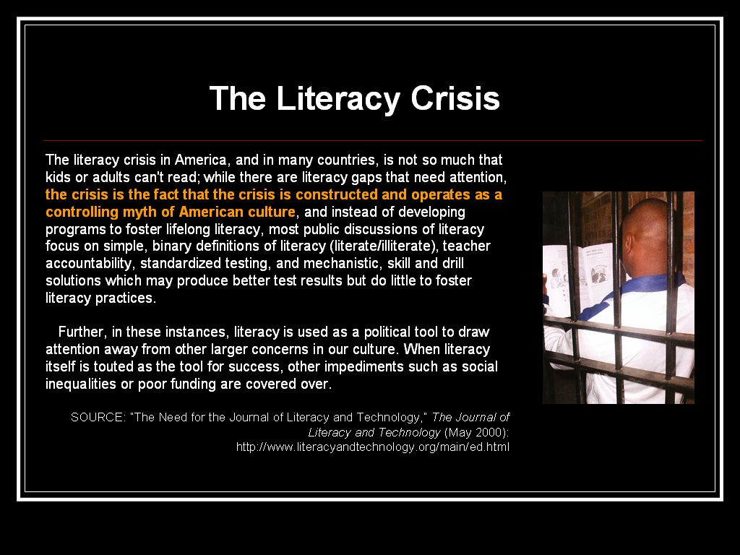
Thus to understand the “literacy crisis” as it is constructed in the media, in our public policies, and in many of our classrooms, it is important for us to examine the ways in which literacy is, in fact, put to use. To do otherwise is to contribute to a phenomenon Brian V. Street calls the “pedagogization of literacy.” As Street explains, “literacy has become associated with educational notions of Teaching and Learning and with what teachers and pupils do in schools, at the expense of the many other uses and meanings of literacy evident from comparative ethnographic literature” (Social Literacies, 106).
Thus, as Lauren B. Resnick argues, “To understand the literacy crisis and imagine possible solutions, it is essential to examine the nature of literacy practice outside of school as well as within. (Resnick, qtd. in Carter 117). That is exactly what we are attempting to do here.
The purpose of our presentation is not to suggest that college composition should prepare writers to fill out and read forms like the texts that mediate the lineman’s daily work. Rather through presentations like these we hope to force to the surface the intellectual viability of alternative literacies and, perhaps even more importantly, the problem with vague assertions that the goal of college composition is to teach writing.
It is also a call for writing instructors to begin asking their students to investigate out-of-school literacies through their own ethnographic research. In our Basic Writing Program and—this year—the second semester of first-year composition, the subject is literacy as it manifests itself in particular contexts, among particular people, and for particular purposes. In doing so, we are working from a theoretical framework I have been calling rhetorical dexterity: “an approach that develops in students the ability to effectively read, understand, manipulate, and negotiate the cultural and linguistic codes of a new community of practice based on a relatively accurate assessment of another, more familiar one” (Carter 22). It is a framework shaped by critical theorists like Henry Giroux and Harvey Graff, key scholars in the New Literacy Studies like James Paul Gee and Brian V. Street, and activity theorists like David Russell and Etienne Wenger, and one I have found very useful in my work as a teacher, teacher trainer, researcher, advocate, and scholar. That is, we ask our students to investigate literacy in a particular context beyond the school (the football field, a community of MySpace profiles, the nurse’s station at a local hospital, electrical line work) and compare those with the ways they function in the school-based contexts they are joining. In other words, we teach writing by articulating and helping our students articulate the way literacy actually lives, which, as Deborah Brandt explains, places greater pressure on Americans, “not to meet higher literacy standards as has been so frequently argued elsewhere but rather to develop a flexibility and awareness” (651, emphasis mine). As I had experienced and envisioned it (at least before working with my co-presenter here), when successfully delivered, a pedagogy of rhetorical dexterity develops in students the flexibility and what Lisa Ede calls “rhetorical sensitivity” necessary to negotiate the multiple, always changing literacies that are certain to exist beyond our classroom’s walls.
From these student essays (in English 100 and, thus far, in English 102), I’ve learned a lot about teaching and the diverse and rigorous literacies our students bring with them (Bible-based literacy, gaming literacy, fishing literacy, literacy as a barber or a game-room attendant). However, it was not until Stephen introduced me to Johnny last fall that a first year student essay would change my thinking about the field itself. Before this point, my use of student writing had been as object to be analyzed, serving as, what Amy Robillard describes as an “instantiation of the pedagogical apparatus that . . . historically accompanies the publication [or presentation] of student writing” (213). It was Stephen who decided to explore the mechanisms by which his functionally illiterate colleague negotiated the print-based tasks that detailed and documented his daily work. It was Stephen who concludes from this exploration that in the workplace—at least the workplaces with which he’s most familiar—literacy is a collaborative activity, not an individual one. It was Stephen who confirmed for me the importance of a reciprocal relationship like the one he had with Johnny. As he put it in his final essay last fall, “[Johnny] taught me a lot about line work and I taught him a little about writing and reading. We worked well together. . . As I worked as an outsider to this community of practice, it would not be long before I was a literate insider. Doing the same work that he had taught me, now with me up in the bucket. Johnny was now my overqualified grunt looking over me, making sure I didn’t do something that might get me killed” (Williams 2-3).
It was Stephen who changed my mind about literacy, contributing to the scholarly conversation in literacy in significant and meaningful ways.
In her 1998 book Reflection in the Classroom, Kathleen Blake Yancey describes a similar mind shift, which for her was brought about several years ago by her job as a sales rep at a “south central Pennsylvania factory that manufactures mobile homes.” Having herself grown up in the suburbs of DC, for Yancey, at least up until that point, literacy appeared monolithic, a version of literacy that, as we know, is ubiquitous, reproduced in middle-class homes, neighborhoods, and schools, and “the dominant discourse, mainstream variety.””
At that Pennsylvania factory, however, literacy was something else.
Whatever counts as literacy here—and it’s a lot, from a kind of seasonal rhythm they find constructive but that I don’t recognize, to the knowledge required to hunt a deer and turn it into something we’d want to eat, to the history of this place and its people—its not my suburban textbook literacy” (170).
Johnny’s literacy isn’t my “suburban textbook literacy” either. It is, as Stephen explains, literacy through teamwork. “You don’t necessarily have to know how to read and write to be a literate person. Johnny was proof of this. He was a literate lineman,”

By focusing on literacy as both an object of scholarly inquiry and the product reproduced through said scholarly activities, we treat first-year composition, according to Downs and Wardle’s forthcoming CCC’s article, as "a course about how to understand and think about writing in school and society" (9). By focusing on literacies as they exist in context, and asking students to contribute to this scholarly conversation, we help these beginning college writers develop a better understanding of "the ways writing works in the world and how the 'tool' of writing is used to mediate various activities" (9). More importantly, we make that writing really matter--not as an empty exercise but as a chance to create real knowledge—knowledge that changes how think about literacy and literacy acquisition and that should, therefore, change how we go about teaching it. Knowledge that continues to change me and what it means to teach writing.

