List of Princes of Liechtenstein
# | Picture | Name | Prince From | Prince Until
1 | 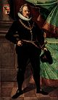 | Karl I | 20 December 1608 | 12 February 1627  (18 years, 54 days)
2 | 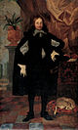 | Karl Eusebius | 12 February 1627 | 5 April 1684  (57 years, 53 days)
3 | 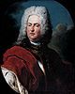 | Hans-Adam I | 5 April 1684 | 16 June 1712  (28 years, 72 days)
4 | 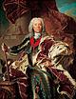 | Josef Wenzel I | 16 June 1712 | 12 March 1718  (5 years, 269 days)
5 | 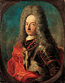 | Anton Florian | 12 March 1718 | 11 October 1721  (3 years, 213 days)
6 | 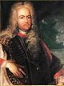 | Josef Johann Adam | 11 October 1721 | 17 December 1732  (11 years, 67 days)
7 | 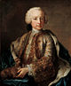 | Johann Nepomuk Karl | 17 December 1732 | 22 December 1748  (16 years, 5 days)
4 |  | Josef Wenzel I | 22 December 1748 | 10 February 1772  (23 years, 50 days)
8 | 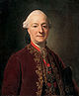 | Franz Josef I | 10 February 1772 | 18 August 1781  (9 years, 189 days)
9 | 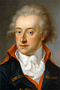 | Aloys I | 18 August 1781 | 24 March 1805  (23 years, 218 days)
10 | 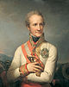 | Johann I Josef | 24 March 1805 | 20 April 1836  (31 years, 27 days)
11 | 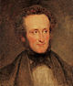 | Aloys II | 20 April 1836 | 12 November 1858  (22 years, 206 days)
12 | 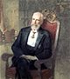 | Johann II | 12 November 1858 | 11 February 1929  (70 years, 91 days)
13 | 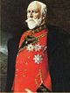 | Franz I | 11 February 1929 | 25 July 1938  (9 years, 164 days)
14 | 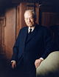 | Franz Josef II | 25 July 1938 | 13 November 1989  (51 years, 111 days)
15 |  | Hans-Adam II | 13 November 1989  (25 years, 190 days) | Present

