Belgium
Independent Kingdom 1830
(Kings)
 | 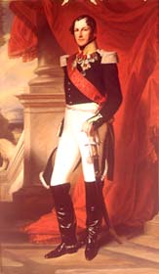 | Leopold I (1790-1865) | 21.07.1831-10.12.1865
 | 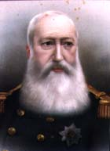 | Leopold II (1835-1909) | 17.12.1865-17.12.1909
 | 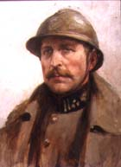 | Albert I (1875-1934) | 17.12.1909-17.02.1934
 | 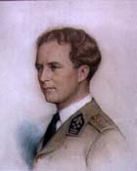 | Leopold III (1901-1983) | 23.02.1934-16.07.1951  Abdicated.
 | 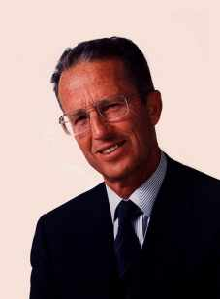 | Baudoin I (1930-1993) | 17.07.1951-31.07.1993
 | 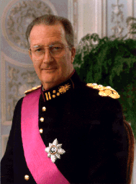 | Albert II (1934-) | 09.08.1993-21.07.2013  Abdicated.
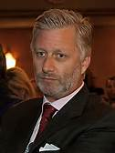 |  | Philippe I (1960-) | 21.07.2013-

