Luxembourg
Grand Duchy 31.05.1815; until 1890 in personal union with the Netherlands
(Grand Dukes)
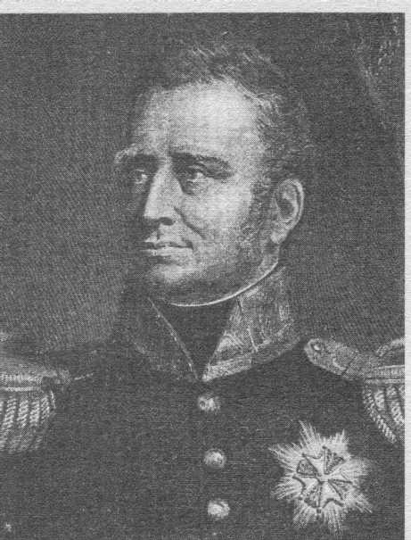 | Willem I (1772-1843) | [02.12.1813]-07.10.1840
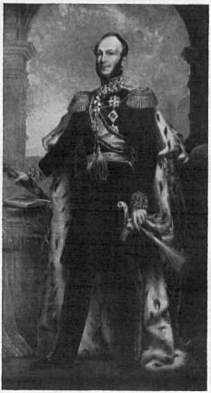 | Willem II. (1792-1849) | 07.10.1840-17.03.1849
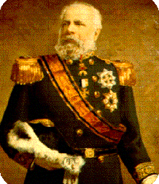 | Willem III. (1817-1890) | 17.03.1849-23.11.1890
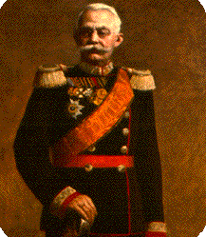 | Adolf (1817-1905) | 23.11.1890-17.11.1905
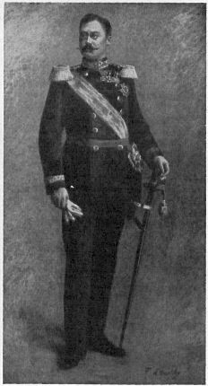 | Wilhelm IV (1852-1912) | 17.11.1905-25.02.1912
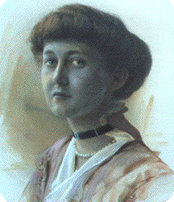 | Marie Adelaide (1894-1924) | 25.02.1912-14.01.1919
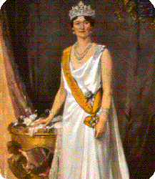 | Charlotte (1896-1985) | 14.01.1919-12.11.1964
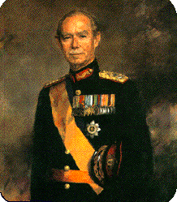 | Jean (1921) | 12.11.1964-07.10.2000
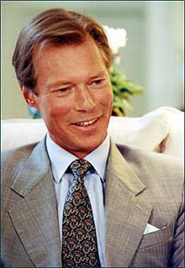 | Henri (1955) | 07.10.2000-

