Sweden
Kingdom since the 10th century, personal union with Denmark and Norwy 1389-1523, with Noway 1814-1905
(Kings/Queens)
 | Bjoern the Old (-950) | 900-950
 | Erik VII the Victorious (-994) | 950-994
 | Olof III Skoetkonung (-1022) | 994-1021/1022
 | Anund Jacob | 1021/1022-1050
 | Emund (-1056) | 1050-1056
 | Stenkil (-1066) | 1060-1066
 | Inge I (-1112) | 1080-1112
 | Halstan | 1080
 | Blot Sven | 1080/1090
 | Philipp (-1118) | 1112-1118
 | Inge II (-1130) | 1118-1130
 | Sverker I (-1156) | 1130-1156
 | Erik IX (-1160) | 1150/56-18.05.1160
 | Carl VII Sverkersson (-1167) | 1156/1160-1167
 | Knut Eriksson (-1196) | 1167-1196
 | Sverker II (-1210) | 1196-1208
 | Erik X Knutsson (-1216) | 1208-1216
 | Hans I Sverkersson | 1216-1222
 | Erik XI (-1250) | 1222-1229
 | Knut Långe (-1234) | 1129-1234
 | Erik XI (2nd time) | 1234-02.02.1250
 | Waldemar Birgersson (-1302) | 1250-1278
 | Birger Jarl (-1266) (Regent) | 1250-1266
 | Magnus I Birgersson Ladulås | 1278-1290
 | Birger Magnusson (-1321) | 1290-1319
 | Magnus II (1316-1374) | 1319-1363
 | Håkon Magnusson (1340-1380) | 1362-1363
 | Albrecht (1340-1412) | 1364-1389
 | Margarete (1353-1412) (s. Denmark) and (Norway) | 1389-28.10.1412
 | Erik XIII (1382-1459) (s. Denmark) and (Norway) | 1397-1439
 | Christoph (1418-1448) (s. Denmark) and (Norway) | 09.04.1440-06.01.1448
 | Carl VIII Knutsson (1408-1470) | 20.06.1448-24.06.1447
 | Christian I (1425-1481) (s. Denmark) and (Norway) | 24.06.1447-1464
 | Carl VIII Knutsson (2nd time) | 1464-01.1465
 | Carl VIII Knutsson (3rd time) | 1467-1470
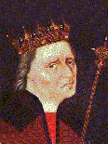 | Christian I (2nd time) (s. Denmark) and (Norway) | 1470-10.10.1471
 | Sten Sture the Older (-1503) (Regent) | 1470-1495
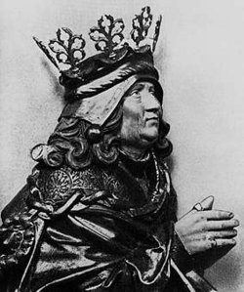 | Hans II (1455-1513) (s. Denmark) and (Norway) | 11.1497-1501
 | Sten Sture the Older (2nd time) (Regent) | 11.1501-14.12.1503
 | Svante Nilsson Sture (1460-1512) (Regent) | 1504-02.01.1512
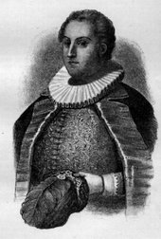 | Sten Svantesson (= Sten Sture the Younger) (1492-1520) (Regent) | 1512-03.02.1520
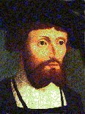 | Christian II (1481-1559) (s. Denmark) and (Norway) | 06.03.1520-25.01.1523
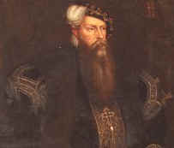 | Gustaf I Wasa (1496-1560) (Regent since 08.1521) | 06.06.1523-29.09.1560
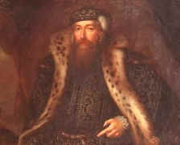 | Erik XIV (1533-1577) | 29.09.1560-30.09.1568
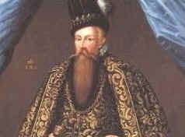 | Johan III (1537-1592) | 30.09.1568-17.11.1592
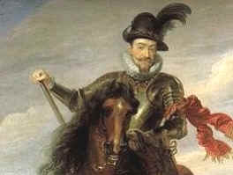 | Sigismund (1566-1632) | 17.11.1592-11.1600
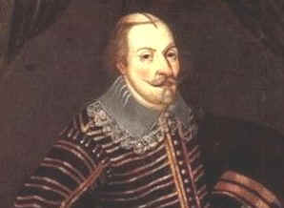 | Carl IX (1550-1611) | 22.03.1604-30.10.1611
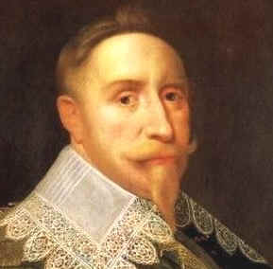 | Gustaf II Adolf (1594-1632) | 30.10.1611-16.11.1632
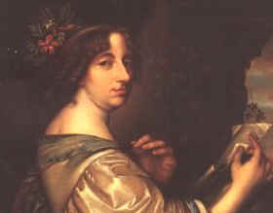 | Christina (1626-1689) | 17.11.1632-16.06.1654
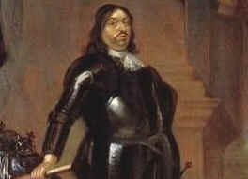 | Carl X Gustaf (1622-1660) | 16.06.1654-23.02.1660
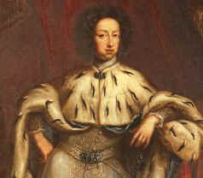 | Carl XI (1655-1697) | 23.02.1660-15.04.1697
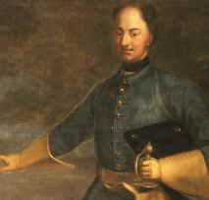 | Carl XII (1682-1718) | 15.04.1697-11.12.1718
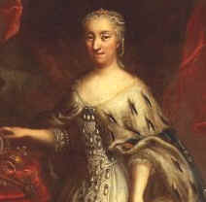 | Ulrike Eleonore (1688-1741) | 23.01.1719-24.03.1720
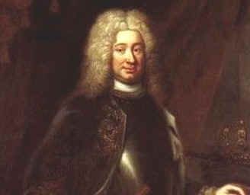 | Frederik I (1676-1751) | 24.03.1720-05.04.1751
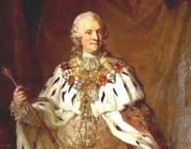 | Adolf Frederik (1710-1771) | 05.04.1751-12.02.1771
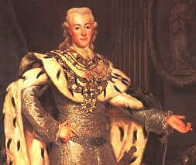 | Gustaf III (1746-1792) | 12.02.1771-29.03.1792
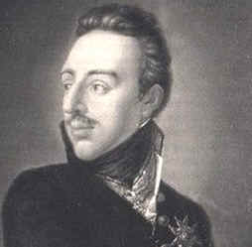 | Gustaf IV Adolf (1778-1837) | 29.03.1792-13.03.1809
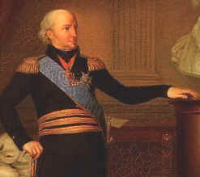 | Carl XIII (1748-1818) (s. Norway) | 20.06.1809-05.02.1818
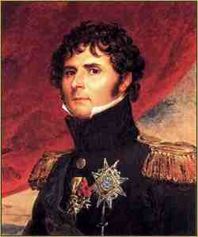 | Carl XIV Johan (1764-1844) (s. Norway) | 05.02.1818-08.03.1844
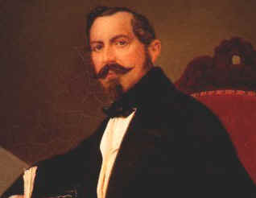 | Oscar I (1799-1859) (s. Norway) | 08.03.1844-08.07.1859
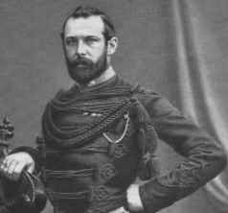 | Carl XV (1826-1872) (s. Norway) | 08.07.1859-18.09.1872
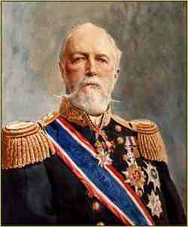 | Oscar II (1829-1907) (s. Norway) | 18.09.1872-08.12.1907
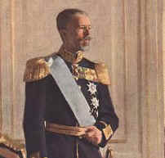 | Gustaf V (1858-1950) | 08.12.1907-29.10.1950
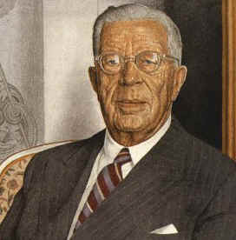 | Gustaf VI Adolf (1882-1973) | 29.10.1950-15.09.1973
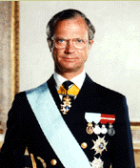 | Carl XVI Gustaf (1946) | 15.09.1973-

