“Suppose we adopt alternative orienting assumptions about development that, I believe, are both more consistent with the data and more helpful in understanding change” (p. 86).
Siegler, R.S. 1996. Emerging Minds: The Process of Change in Children’s Thinking. Oxford.

Developmental Cascades

April 25, 2024
Arlington, Texas
Daniela Uribe Montserrat  Doctoral student in Educational Innovations  Tecnológico de Monterrey, México | Josh Thompson, Ph.D.  Professor, Early Childhood Care and Education  Texas A&M University-Commerce, US
http://faculty.tamuc.edu/jthompson/co-lab

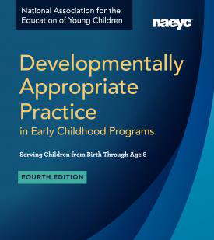 | National Association for the Education of Young Children. (2020). Developmentally Appropriate Practice: A Position Statement. NAEYC.
Turn and Talk | When did you first hear about DAP?  How do you see DAP in Texas classrooms and learning centers?
Theories of Development | 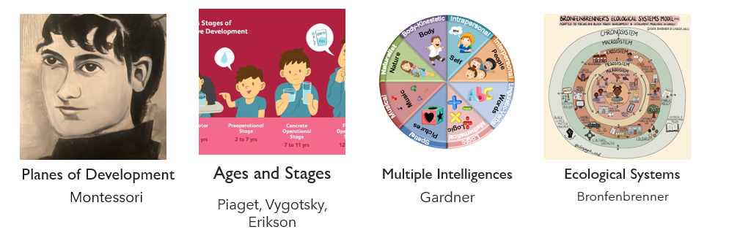
Turn and Talk | How do Theories of Development affect teachers’ Image of the Child?  How does learning about Theories of Development help teachers change and grow?
“A simple liberating thought came to our aid, namely that things about children and for children are only learned from children. Follow the child.” Malaguzzi, L. 1998. The Hundred Languages of Children: The Reggio Emilia Approach – Advanced Reflections. Ablex, p. 51.

Overlapping Waves  Siegler, 1996 | 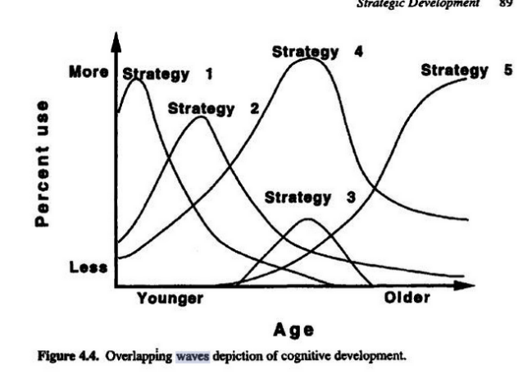
Masten, A. S., & Cicchetti, D. (2010). Developmental cascades. Development and Psychopathology, 22(3), 491–495. https://doi.org/10.1017/S0954579410000222

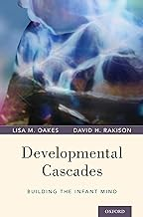
“A cascade can be used as a metaphor for thinking about development. Abilities begin at the top of the cascade and move down along different trajectories depending on which rocks and obstacles are encountered along the way. All drops of water, or developing abilities, end up in the pool below, but the particular position in the pool depends on the path traveled, which reflects the events and objects encountered along the way” (p. 103).

Oakes, L. M., & Rakison, D. H. (2020). Developmental cascades : building the infant mind. Oxford.

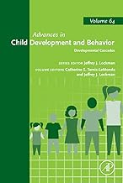 | “Children develop along any number of paths depending on factors such as how much freedom they are given to move, their relative size, the kind of caregiving they receive, and how language is spoken to them, and much more. It’s important to not consider differences as a way to identify deficits… understand how experience influences the shape of the cascade.”  Tamis-LeMonda, C. S., & Lockman, J. J. (Eds.). (2023). Developmental Cascades. Academic Press.
Key Tenants of Cascade Approach
- All developmental change reflects the use of multiple mechanisms
- The mechanisms of any specific developmental change operate at many levels involving sensation, perception, and cognition
- The emergence of any behavior or milestone represents one point in an ongoing developmental cascade

Key Points of Developmental Cascades
- Bidirectional Effect: Milestones influence development; development reinforce or reshape earlier skills.
- Impact Across Domains: Cascades can occur within a single domain (ex: motor skills improve athleticism), or across different domains (social skills = better academic performance).
- Cumulative Effect: Small successes or struggles early on can have a snowball affect over time, leading to advantages or disadvantages.
- Not Predetermined: While cascades suggest a path of influence, it’s not a fixed destiny. Children are adaptable, and environmental factors, interventions, and individual differences can modify the course of development.

Please take our survey
Español  https://forms.gle/HyKBc1bDGKwJXepm9 | English https://forms.gle/nXfBst4Pj4g3KdgP9

CO-LAB: 9 interdisciplinary research scholars, international, multi-disciplinary
Catalina Murcia, Casa de Paz Montessori, Dallas
Daniela Uribe Montserrat, Tecnológico de Monterrey
Danielle McLellan-Bujnak, Respectful Care® for Nannies & NCS
Josh Thompson, Texas A&M University-Commerce
Karen Walker, Texas A&M University-Commerce
Marta Mercado-Sierra, Texas A&M University-Commerce
Melissa Heinrich, The University of Texas at Dallas
Rachael Rose, Seattle, WA, USA
Zlata Stankovic-Ramirez, The University of Texas at Dallas

Daniella Uribe Montserrat  daniela.um@gmail.com | Josh Thompson, Ph.D.  josh.thompson@tamuc.edu
http://faculty.tamuc.edu/jthompson/co-lab

