ELPS Inform Instruction

By Dr. Kristan Nicole Pearce, Fall 2024

# Foundation of English Language:

* Understand students’ language proficiency levels to accommodate academic and essential vocabulary linguistically
* Allow students to practice oral and written forms of grammar and syntax during cooperative and independent tasks
* Provide students with a linguistic platform to build on and advance to the next proficiency level
* Include elements of the four language domains during content-based instruction

# Language Domains

The English learner uses language learning strategies to develop an awareness of his or her learning processes in all content areas.

* For each of the four language domains, listening, speaking, reading, or writing, EB students may be at the beginning, intermediate, advanced, or advanced high stage of English language acquisition.
* The ELPS Proficiency Level Descriptors (PLDs) guide for educators to design and deliver grade-level, content-based instruction in conjunction with foundational English language acquisition scaffolds (TEA ELPS Instructional Tool).
* The English learner uses language learning strategies to develop an awareness of his or her learning processes in all content areas.

#### Listening:

* The English learner listens to a variety of speakers such as teachers, peers, and electronic media to gain an increasing level of comprehension of newly acquired language in all content areas;

#### Speaking:

* The English learner speaks in a variety of modalities for various purposes and is aware of different language registers, both formal and informal, using vocabulary with increasing fluency and accuracy in all content areas;

#### Reading:

* The English learner reads a variety of texts for various purposes with an increasing level of comprehension in all content areas.
  + In Kindergarten and Grade 1, certain student expectations will apply to text read aloud for students not yet at the stage of decoding written text.

#### Writing:

* The English learner writes in a variety of forms with increasing accuracy and can effectively address a specific purpose and audience in all content areas.
  + For Kindergarten and Grade 1, certain student expectations will not apply until the student has reached the stage of generating original written text using a standard writing system (TEA, 2012b).

## Receptive & Productive language skills

* reading and listening are receptive language skills
* writing and speaking are productive language skills

#### The interrelatedness of language skills

* all integrated and contribute to one’s understanding of the world
* substantial correlations between these four language processes.
  + When students are engaging in one language domain, they are also advancing their other language skills, as described in the following connections:

##### Oral Skills (Listening and Speaking):

* + - * As listening and speaking are interrelated, improving listening skills will have an impact on a student’s ability to learn to speak a new language.

##### Academic Skills (Reading and Writing):

* + - * Reading and writing draw upon shared knowledge bases and work together to help students learn about a particular subject.

##### Receptive Skills (Listening and Reading):

* + - * Higher-level language skills are critical to strong reading comprehension and its development. Language skills can be developed while listening during targeted instruction and discussions and can contribute to increased comprehension when reading. Progress monitoring must be implemented to meet the needs of all students in these areas.

##### Productive Skills (Speaking and Writing):

* + - * There is a high correlation between the level of speaking and the level of writing. The higher the level of speaking, the better the writing skills of a student (Nan, 2018).

# ELPS

English Language Proficiency Standards (ELPS)

* second language acquisition curriculum for EB students
* ELPS and students’ proficiency levels are provided in Competencies 2 and 3. 65

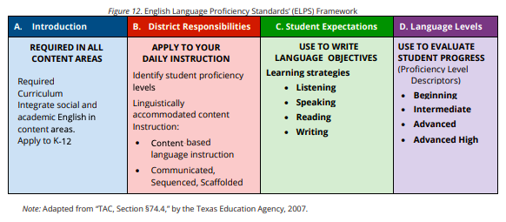

### Application of ELPS

The following components are essential practices for application of the ELPS:

#### Integrate the Skills:

* The four domains of listening, speaking, reading, and writing should be taught in an integrated manner as they are used in authentic communication.

#### Use Content-Based Instruction:

* Students should be provided with opportunities to engage in meaningful communication.
* Teachers should create opportunities for concurrent social and cognitive development.
* Students should also have access to various academic concepts and language functions.

#### Use Task-Based Instruction:

* Teachers should provide opportunities for real-life tasks to combine language with non-linguistic functions.
* Instruction should focus on meaning.
* This type of instruction requires information gathering, comprehension, interaction, and language production (TEA, 2012b).

# Proficiency Level Descriptors

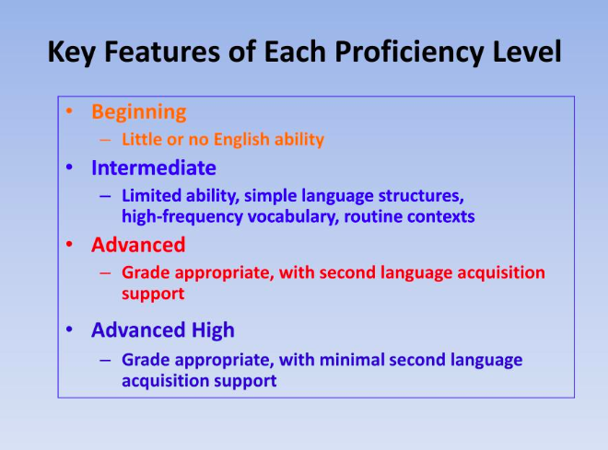

# TEKS & ELPS

TEKS=Content Objectives

ELPS=Language Objectives

### Curriculum design

based on both the TEKS and the ELPS go hand in hand.

* By only setting content objectives, targeted language learning can be neglected, and thus both language and academic content objectives need to be established for students learning a second language (Hill & Miller, 2013).
  + Whereas content objectives are based on the student expectations per the TEKS,
  + language objectives should be based on the language expectations per the ELPS.

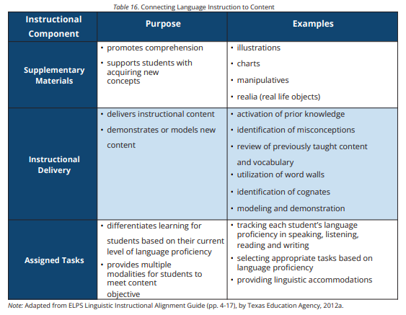

#### Language objectives

* can be a powerful tool for helping EB students make progress in language acquisition and
* may be implemented at any proficiency level to provide access to the curriculum (Himmel, 2018).
* 100 second language acquisition process
  + Echevarría, Short, & Vogt (2008, as cited in Himmel, 2018) remind us that the 100-second language acquisition process requires opportunities for the language learner to be exposed to, practice with, and then be assessed on their language skills.

##### Purpose of Language Objective

The language objective serves the following purposes:

* specifies the academic language functions and skills that students must master to both fully participate in the lesson and meet the grade-level content standards (Echevarría, Short, & Vogt, 2008, as cited in Himmel, 2018).
* benefits both EB students and all other students in class by establishing and outlining clear expectations about the required academic language expectation in any subject area (Himmel, 2018).

#### Designing TEKS-&ELPS-Based Instruction

* Lesson planning=first step in ensuring content-based language instruction happens.
  + Language skills are needed to understand content material.

Planning intentional and targeted language instruction considers three main components:

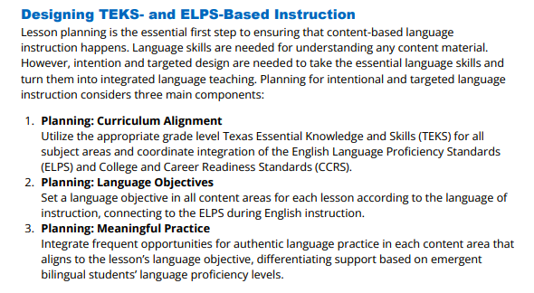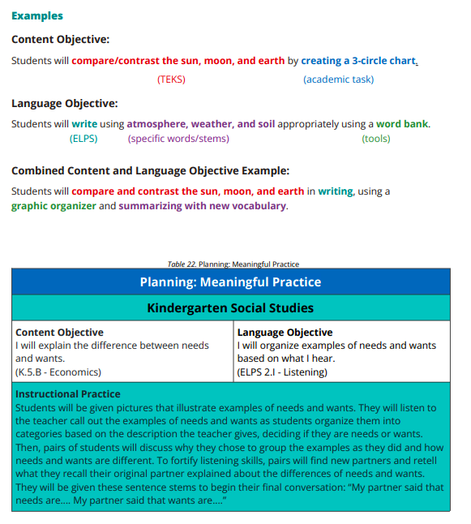

## Supporting Second Language Acquisition (SLA) Through Instructional Design

### Five critical areas

* in which effective instructional design will support emergent bilingual (EB) students’ second language acquisition:

#### Language Conventions and Structures:

* + Understand how increasingly complex language conventions and structures are acquired through frequent language practice opportunities.

#### Expressive and Receptive Language:

* + Engage EB students in routine and structured opportunities to speak, write, read, and listen with peers and independently.

#### Social and Academic Language:

* Identify the differences between basic interpersonal communication skills (BICS) and cognitive academic language proficiency (CALP) and how both are developed and used inside and outside of the school environment.

|  |
| --- |
| BICS & CALP  BICS = social language   * Basic Interpersonal Communication Skills (BICS) refer to linguistic skills needed in everyday, social face-to-face interactions.   CALP = academic language   * Cognitive Academic Language Proficiency (CALP) focuses on proficiency in academic language or language used in the classroom in the various content areas.   <https://www.colorincolorado.org/faq/what-are-bics-and-calp> |

Overall, research suggests ESL teachers should use a student’s knowledge of BICS to build CALP

* through rephrasing or creating connections and
* use the same experiential and meaningful activities that help students acquire BICS to help students develop CALP
* through repeated use and practice of the new vocabulary in context (Cummins, 1981).

#### Vocabulary Development:

* Understand the impact of both direct and context-embedded approaches to vocabulary development for EB students (including vocabulary development in L1 and L2 within bilingual programs).

|  |
| --- |
| Vocabulary Development   * Developing vocabulary requires careful attention to teaching core vocabulary. Practical vocabulary instruction that supports EB students should include strategies such as targeted selection of terms (Tier II and III), for the development of cognitive academic language. There is strong evidence of the link between vocabulary knowledge and academic achievement (Echevarría & Graves, 2003; Marzano, 2003). Thus, one critical consideration for teachers of EB students is the importance of fostering an ample vocabulary, especially academic vocabulary that is subject-specific. * Marzano (2003) proposes a balanced approach between the direct and indirect methods of vocabulary instruction where students:   + are engaged in wide reading about subject matter content and content of their choice   + receive direct instruction on words and phrases that are critical to their understanding of academic content   + are exposed to new words multiple times; and   + are encouraged to elaborate on their understanding of new words using mental images, pictures, and symbols (pp. 140-141). * In the early stages of language acquisition, targeted and systematic pre-teaching of key vocabulary in context benefits EB students (Hill & Miller, 2013). This will allow EB students to become familiar with Tier II (academic discourse) and Tier III (subject-specific) vocabulary words. It is important to emphasize again that pre-teaching vocabulary involves a targeted selection of key terms from Tier II and Tier III through meaningful activities that will have the most impact on student comprehension. Vocabulary words must be carefully selected, chunked into manageable units, and practiced through activities that involve engaging and interactive learning strategies. |

#### Interaction:

* Recognize the role that peer-to-peer interaction plays inside and outside the classroom in SLA.

|  |
| --- |
| Interaction   * Student interaction requires multiple grouping configurations. * Interaction is a critical component in promoting language acquisition (Lessow-Hurley, 2003). Students need to be provided multiple opportunities to engage in academic conversations during class. * Cooperative learning provides students with a structure to engage in such interactions.   + Additionally, this strategy promotes content and language development due to the opportunities created for students to interact and communicate with their classmates (Lessow-Hurley, 2003). * The foundation for literacy lies in the ample practice of 112 rich oral academic conversations (Hill & Miller, 2013).   + To improve written language output, many opportunities need to be afforded to students to engage in academic discussions (Hill & Miller, 2013). |

# Instructional Activities

* Content-Based Instruction (CBI) primarily focuses on language development through content,
* Accelerated Instruction for EB students at Beginning and Intermediate Levels of English Proficiency in Grades 3 or Higher
* Whatever the case, focused, targeted, and systematic instructional activities will facilitate students’ transition to a higher proficiency level and can be implemented as follows

## Focused:

#### Pre-teach academic and social vocabulary

* to support comprehension during instruction.

#### Build background

* to ensure comprehension during academic tasks. Organize group configurations to support all EB students. Use formative and summative assessments consistently to adjust the level of linguistic accommodations provided.

## Targeted:

#### Identify the lesson’s language objective(s)

* based on the ELPS cross-curricular student expectations.

#### Provide EB students with the tools necessary

* to express themselves in oral and written forms of language.

#### Accommodate activities and materials

* based on students’ levels of language and content proficiency. Plan concentrated and intentional opportunities for academic and social interactions and/or discourse.

## Systematic:

#### Utilize routines and procedures

* that allow students to concentrate on their understanding of content.

#### Cooperative learning interactions

* Encourage and support students’ participation in cooperative learning interactions as they progress in their language proficiency development.

#### Simple to Complex skills

* Recognize second language acquisition as a methodical progression of skills from simple to complex, and plan accordingly.

#### Appropriate level of discourse

* Engage students at the appropriate level of discourse by using scaffolded, probing questions, and/or sentence frames.

# Linguistic Accommodations

Communicated, sequenced, & scaffolded,

* Sheltered instruction focuses on developing academic content across subject areas in conjunction with language development (Echevarría, Vogt, & Short, 2013).
* Although the approach is slightly different, content-based instruction and sheltered instruction have the foundational purpose of making content comprehensible while supporting language development.
* In Texas, sheltered instruction is incorporated within programs for EB students as TAC, §74.4(b) requires instruction to be culturally and linguistically accommodated in a way that is communicated, sequenced, and scaffolded based on the student’s English proficiency level.
  + The three components of linguistically accommodated instruction can be understood as follows:

## Communicated:

### Input to convey meaning

* the comprehensible input used to convey the meaning of key concepts (Krashen, 1982)

## Sequenced:

### Differentiating instruction

* involves differentiating instruction to align with the progression of a student’s language development (Hill & Flynn, 2006), such as visuals, appropriate speech, and other strategies as described throughout Domain II;

## Scaffolded:

### Structured support

* structured support that builds self-efficacy and independent acquisition of both language and content knowledge, as described in Table 24 (Echevarría, Vogt, & Short, 2008).

Additional guidance on communicating, sequencing, and scaffolding instruction based on each student’s English proficiency level can be found in the “Learning Strategies” section within the context of specific learning strategies.

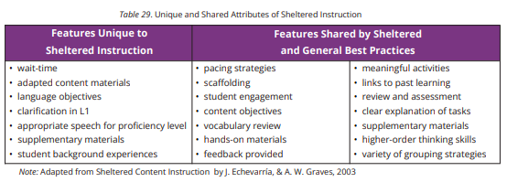

#### Additional Accommodations & Supports

To develop language beyond BICS, EB students may need accommodations and support during the delivery of instruction, which can include:

* scaffolds;
* use of visuals and gestures;
* clear speech;
* Paraphrases;
* repetition of key vocabulary in context;
* summarization of main points;
* limited use of idioms;
* written information – adapted texts, graphic organizers
* strategies – cognates, vocabulary, and reading (Baker, 2006).

### Instructional Practices

The following instructional practices are based on the ELPS Cross-Curricular Second Language Acquisition Essential Knowledge and Skills (TAC, §74.4), under the learning strategies domain:

Visuals

Visuals may include pictures, realia, and video.

* Concrete representations of the content presented are essential for English learner comprehension. As Krashen (2004) explains, objects and pictures can encourage language acquisition by helping the learner understand a message that may otherwise be slightly beyond his or her immediate understanding. Non-linguistic representations serve the dual role of providing students with information and the additional benefit of allowing teachers of EB students to get a more complete idea of students’ knowledge despite their level of English proficiency (Hill & Miller, 2013). Non-linguistic representations allow EB students to express their thinking when they do not yet have a level of English proficiency to express themselves verbally or in writing.
* Marzano (2003) provides the following strategies for non-linguistic representations, asking students to:
  + generate mental images representing content,
  + draw pictures or pictographs representing content
  + construct graphic organizers representing content
  + act out content
  + make physical models of content
  + make revisions to their mental images, pictures, pictographs, graphic organizers, and physical models

Active Learning

Active learning refers to instructional strategies that focus on engaging students as active participants in their learning process (Boyer, 2002), and for EB students, active learning is critical precisely because it maximizes engagement.

* Boyer emphasizes that practicing active learning strategies can have an even deeper impact on learning when implemented as part of a broader student-centered culture.
* These strategies can promote a high-energy and student-centered environment where students are treated with dignity while developing self-awareness, a sense of community, and self-management skills.
* These components of active learning are critical and go far beyond just playing “fun learning games” (Harmin, 1998, as cited in Boyer, 2002).
* Examples of Active Learning Strategies Oral & Written Engagement Strategies Adaptations to Support EB Students

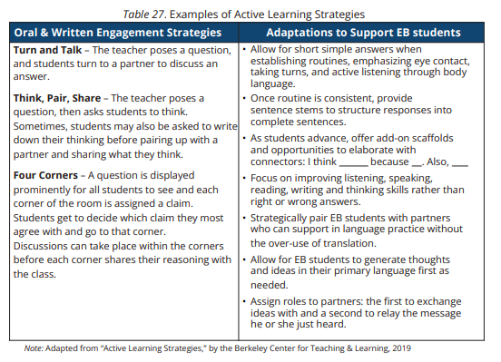

Additional Practices:

* use prior knowledge and experiences
  + to understand meanings in English;
  + EB students benefit from instructional activities and targeted accommodations designed to build on their prior knowledge to confidently practice using newly acquired English language concepts (TEA, 2012b).
* Engage in authentic academic tasks
* For successful learning to occur, authentic academic tasks need to support the learner’s effective communication as it develops as wEB students as the learner’s understanding of the oral and written language (TEA, 2012b).
* monitor oral and written language production
  + and employ self-corrective techniques or other resources;
* use strategic learning techniques
  + such as concept mapping, drawing, memorizing, comparing, contrasting, and reviewing to acquire basic and grade-level vocabulary;
* speak using learning strategies
  + such as requesting assistance, employing non-verbal cues, and using synonyms and circumlocution (conveying ideas by defining or describing when exact English words are not known);
* internalize the new basic and academic language
  + by using and reusing it in 69 meaningful ways in speaking and writing activities that build concept and language attainment;
* use accessible language
  + and learn the new and essential language in the process;
* demonstrate an increasing ability to distinguish between formal and informal English
  + and an increasing knowledge of when to use each one commensurate with grade-level learning expectations; and
* develop and expand the repertoire of learning strategies
  + such as reasoning inductively or deductively, looking for patterns in language, and analyzing sayings and expressions commensurate with grade-level expectations (TEA, 2009).
* ensuring the content is comprehensible
  + Instructional practices that include deliberately modeling, using appropriate speech, and providing clear explanations of academic tasks, rather than just the information are critical for ensuring the content is comprehensible and emphasize that students must acquire language to produce it rather than simply memorizing information (Echevarría, Vogt, & Short, 2012).

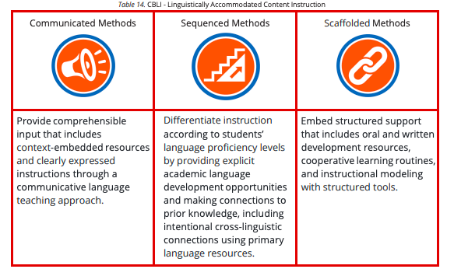

# Learning Strategies

Learning strategies help students monitor their learning.

* A learning strategy as defined by Echevarría and Graves (2003) “is a series of steps that can be repeated over and over again to solve or to complete a problem” (p. 98).
* Learning strategies can be taught to students and be used in multiple settings across contents (Echevarría & Graves, 2003, p. 100).

Academic success can be met by students whose teachers consistently teach and emphasize learning strategies (Reiss, 2012).

## Metacognitive

### Planning for learning

* Monitoring one’s comprehension and production
* Evaluating how one has achieved a learning objective

## Cognitive

### Manipulating material

* Manipulating material to be learned mentally (ex: imagery elaborating)
* Manipulating material physically (ex: group items to be learned, taking notes)

## Social / Affective

### Interacting with another person to assist in learning

* (ex: cooperative learning)
* Asking for clarification
* Using affective control to assist learning tasks

Note: Adapted from The CALLA Handbook (pp. 62-63), by Chamot, A.U., & J. O’Malley, 1994, Reading, MA: Addison-Wesley Publishing Company. Copyright 1964 by Addison-Wesley Publishing Company.

Echevarría, Vogt, and Short’s work (2012) also consider language learning strategies such as

* paraphrasing, word substitution, or breaking down words into their parts such as prefixes and suffixes.

# 

# Language Rich Environment

Supportive, asset-based, comprehensible

P 147

Language Rich Environment: a classroom where students have multiple opportunities to listen to and engage in purposeful conversation with those around them (Seidlitz & Perryman, 2011).

|  |
| --- |
| Defining the Role of the Linguistic Environment and Conversational Support in Second-language Development  A wEB students implemented environment:   * language development is a central focus * content instruction demands higher-order thinking, such as making inferences and critically analyzing literature   + can enhance engagement and challenge students to higher levels of cognitive thinking (Seidlitz & Perryman, 2011).   For EB students,   * allowing them to process and discuss the content   + in a way that is meaningful for them * then building in scaffolds   + so that they can share their thinking orally as a part of second language development * may include allowing students to use their primary language to think out and talk out ideas   + before communicating their response to the language objective in English,     - using appropriate scaffolds.   Law and Eckes (2000) provide the major assumptions to operate under concerning speaking and listening:   * Learners acquire language in an environment that is full of talk that invites response; * Students will speak when they are ready * Fluency precedes accuracy; and * An acceptance of all attempts, whether correct or incorrect, will promote confidence |

## Strategies: Building a Language-Rich Classroom Environment

Essential elements must be present when building a classroom that is conducive to language acquisition in the speaking and listening domain, also referred to as a language-rich environment.

### Supportive

* Create a safe and supportive reading environment that follows a gradual release of responsibility.
  + that lessens the stress and anxiety EB students face in the process of acquiring a new language (Lucas, Villegas & Freeson-Gonzalez, 2008 & Krashen’s (1987) Affective Filter Hypothesis).

|  |
| --- |
| Welcoming and safe environment   * Build a strong classroom community, foster a love of literacy, allow and encourage reading in L1, and provide books that represent students’ experiences.   Response-Ready at all Times:   * Once they have the tools in place to be able to respond, teachers may need to ensure that all students are allowed to speak by randomizing student selection as a formative assessment measure and as a way of maximizing engagement since students do not know who will be called and hence need to be ready at all times (Seidlitz and Perryman, 2011). * Students must be prepared using the appropriate support to provide oral answers, rather than complete “cold calls”.   Response Signals:   * With EB students, allowing appropriate wait time and incorporating low-risk opportunities for them to develop oral responses is another important consideration. * Three types of response signals include:   + written response - allowing students to write on a whiteboard, for example, then hold up their answer before engaging in an oral response with a neighbor;   + ready response - allowing wait time and for students to signal (i.e. raise a fist when they are ready, or the number of fingers to represent minutes they still need);   + making choices - allowing students to choose how to respond (i.e. going to the corner of the room they most agree with); and ranking - allowing students to rate on a given scale (i.e. raise your arm - the higher, the more you agree with a response).   Appropriate Feedback  Consider the following recommendations for providing appropriate feedback on language as wEB students as content for teachers of EB students:   * Strengths-based feedback   + Provide feedback that addresses what is correct and elaborates on what students need to do next; restate using the correct grammar as a model,     - but do not overemphasize. * Timely feedback * Provide feedback appropriately in time to meet students’ needs. * The timing of the feedback is contingent on the task.   + For complex knowledge and skills, provide real-time feedback to avoid misconceptions or erroneous practices.   + On the contrary, during the application of knowledge, such as writing an essay, delayed feedback is preferred to allow students to self-correct. * Criterion-referenced feedback   + Provide criterion-referenced feedback.   + Provide feedback to students with the use of rubrics.     - The rubrics should inform students of their progression toward a particular learning objective.   Student engagement   * Engage students in the feedback process. * Students become part of the feedback process when allowed to work in pairs or small groups.   + Small groups can also reduce the anxiety EB students may experience. * This strategy serves a dual purpose in supporting language acquisition and academic learning through reciprocal teaching (Dean et al., 2012; Hill & Miller, 2013). |

### An asset-based approach to EB students

* Promote students’ self-efficacy.

|  |
| --- |
| Consider:   * the student’s first language proficiency (listening, speaking, reading, and writing), * the student’s current English language proficiency * similarities and differences between the student’s first language and English (cognates and written features) * the student’s background knowledge and opportunities * the student’s access to language at home   Recognize:   * The students' unique experiences and perspectives are beneficial to their learning.   + Get to know students' strengths and struggles to improve instruction for EB students.   + Use activities like the "I wish my teacher knew … " prompt to build trusting relationships. * The student is filled with potential:   + Educators have the opportunity to help them reach it.   + With a dedicated plan and commitment to action, we can change outcomes for every student in our schools.   By:   * Providing books that represent students:   + Include selections that represent students and their experiences to help them feel connected, build community, and motivate them to read (Rudine Sims Bishop’s *Mirrors, Windows, and Sliding Glass Doors*) * Factoring in student choice and interest:   + Allow students to choose reading materials that interest them and remove limits on reading in their primary language to leverage their assets and increase engagement. * Increasing student talk and interaction:   + Provide multiple opportunities for students to listen, speak, read, and write in English.   + Create space for students to discuss their reading to enhance comprehension and engagement. * Using strategic scaffolding:   + Begin with appropriately challenging materials and provide support as necessary.   + Use scaffolds such as multiple representations in math or sentence framing to help students communicate their mathematical thinking |

### Comprehensible

* + Support English proficiency and leverage students’ first language.
  + Use English Language Proficiency Standards and grade-level state standards to guide students in listening, speaking, reading, and writing.

|  |
| --- |
| Teaching Students What to Say:   * Establish the expectation to respond with either their thinking or a clarifying question when a question is posed to them.   + For example, instead of “I don’t know”, students should be expected to respond with either I think… or Could you explain...? * The question may need to be scaffolded for students who are not yet at the oral language production stage so that they can gesture or point a response.   Teach Students to Respond in Complete Sentences:   * As the teacher sets expectations for quality academic responses, it is equally important for those responses to be in complete sentences and strive to use academic language. * Word walls can assist in providing additional vocabulary for students to have access to the language.   Vocabulary and Visuals:   * Creating a classroom environment that is rich in purposeful text and visually rich walls in the form of anchor charts, word walls, graphic organizers, timelines and any additional visual aids that increase EB students’ access to comprehensible input is also clearly an important component for making the language accessible.   Structured Conversations:   * Teachers model structured conversations and should make an intentional effort to speak using academic language within a context that   Incorporating Reading, Writing, and Strategies:   * Because of the interrelatedness of the four components of language( listening, speaking, reading, and writing),   + academic conversations, when complemented with a reading and writing component, provide a benefit to all students, especially EB students. * An English learner’s classroom must account for this interrelatedness by providing students opportunities not only to listen and engage in rich academic conversations with their teacher and peers but they should also be given opportunities to read and write consistently. |