Have We Embraced DAP in Texas Policy?
Texas AEYC Annual Conference
Session Speaker: Dr. Josh Thompson Session Date: 11-02-2023
Session Room: Acacia Session Time: 8:30 AM – 10:00 AM

http://faculty.tamuc.edu/jthompson/dap
Agenda
Developmentally Appropriate Practice DAP
Texas Policy
Action Steps
Discussion Questions – that’s what I like about Texas!
DQ1: How and when did you first come across DAP?
DQ2: How does your use of technology enhance children’s development and well-being?
DQ3: Do you see DAP show up in Texas classrooms, schools, and learning spaces? Have we embraced DAP in Texas policy? If so, how?
DQ4: Are you an advocate for DAP in Texas classrooms, schools, and learning spaces? How will you show up for the child?
NAEYC. (2020, 2022). Developmentally Appropriate Practice in Early Childhood Settings Serving Children from Birth Through Age 8. National Association for the Education of Young Children.
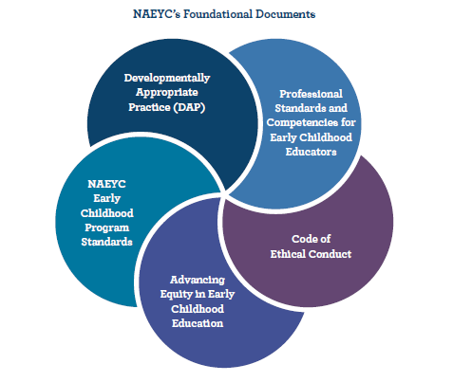
Three Core Considerations to Inform Decision Making
I. Commonality
II. Individuality
III. Context
Nine Principles of Child Development and Learning
1. Nature AND Nurture
2. Domains | 3. Play
4. Variations | 5. Constructivist
6. Motivation | 7. Integrated
8. ZPD | 9. Tech

http://faculty.tamuc.edu/jthompson/dap
Please take our Survey: What Educators Know about DAP
Josh Thompson, Ph.D. (he, him) Safe Space
My passion is to promote and protect childlike wonder and love of learning through play.
http://faculty.tamuc.edu/jthompson
Professor of Early Childhood Education
Department of Curriculum & Instruction
P: 903.886.5537 | C: 214.663.6102
The land I live and work on has been cared for by Indigenous peoples, Caddo, Comanche, Kikapoi, Tawakoni, Wichita, and others.

