Running head: GOING DEEPER WITH MULTICULTURAL EDUCATION

Going Deeper with Multicultural Education

Paula Doskocil, Kim Horn, Laurin Mapes, and Roosevelt Nivens

Texas A & M University at Commerce

Table of Contents

- Title Page…………………………………………………. 1
- Table of Contents…………………………………………. 2
- Agenda……………………………………………………. 3
- Rationale………………………………………………….. 3
- Overview………………………………………………….. 4
- Objectives…………………………………………………. 4
- Components of Multicultural Education………………….. 4
- Concepts of Multicultural Education……………………… 4
- Myths Associated With Multicultural Education…………. 5
- Perspectives……………………………………………….. 5
- A Look at Various Programs Implemented in the U.S…… 5
a. Content-Oriented Programs………………………… 5
b. Student-Oriented Programs………………………… 6
c. Socially-Oriented Programs………………………… 6
XII. Activities…………………………………………………… 6
XIII. Technology………………………………………………… 7
XIV. Conclusion…………………………………………………. 7
XV. Appendixes………………………………………………….
i. Workshop Evaluation………………………………… 8
ii. Candy Activity……………………………………….. 9
iii. Follow the Drinking Gourd Activity……….……….. 10
iv. Follow the Drinking Gourd Map #1………………... 11
v. Follow the Drinking Gourd Map #2………………… 12
vi. Where the Forest Meets the Sea Activity………… 13-14
vii. Where the Forest Meets the Sea Worksheet……….. 15
viii. Getting Started Activity……………………………. 16
ix. Exchanging Stories- Name Activiy………………… 17
x. In the Spirit of Harambe……………………………. 18
XVI. Recommended Books…………………………………… 19-20
XVII. Recommended Web Sites……………………………… 21-22
XVIII. References………………………………………………….. 23

Agenda for Going Deeper with Multicultural Education

- Introduction: Candy Activity (10 minutes)

- PowerPoint presentation (25 minutes)

- Drinking Gourd Activity (20 minutes)

- Dragon Eyes Activity (20 minutes)

- Closing (5 minutes)

- Evaluation (10 minutes)

Rationale

Growth of Minorities in Schools in Midlothian

In 1991, the percentage of minority students enrolled in the Midlothian School

District was 11 percent. In 1995, four years later, the minority population increased one

percent. By 2000 the population had only increased by 2 percent in a ten-year span

(Paschal, 2001).

Due to the growth of ethnic and cultural diversity in the public school population,

an added component of multicultural education needs to be integrated in all curricula

areas throughout the year.

Efforts must be made in order to meet the needs of all students by integrating

multicultural viewpoints and histories, applying instructional strategies that encourage all

students to achieve, and to prepare teachers to promote meaningful, engaged learning for

all students, regardless of their race, gender, ethnic heritage, or cultural background

Overview

This presentation is designed to show educators the need for a multicultural curriculum that is integrated into all subject areas. The introduction begins with a brief candy activity, which demonstrates how human nature tends to steer away from the unknown. The areas discussed in the PowerPoint are growth of minority students, myths associated with multicultural education, program types in the United States, and it concludes with a social studies activity showing African-American oppression.

Objectives
Objectives for this multicultural workshop include: a) teachers and students will demonstrate respect towards cultural differences all year to insure equity of opportunity to learn and b) the teacher will recognize that opportunities to teach multiculturally exist in all areas of the curriculum.

Components of Multicultural Education

Ethnic, minority, women’s, and religious studies

Bilingual education and English as a second language

Cultural and global awareness

Human relations and conflict resolution

Special education

Concepts of Multicultural Education

* Racism * Stereotyping * Sexism

* Classism * Ageism * Prejudice

* Discrimination * Oppression * Powerlessness

* Power * Inequality * Equality

Myths Associated with Multicultural Education

Other cultures should be presented as distinct ways of living that reflect differences

from the dominant culture. Bilingualism is a liability rather than an asset. There should

be separate, unified set of goals and curriculum for Multicultural Education. Multicultural

education is only relevant in classes with students who are members of the cultural or

racial groups to be studied. Mere activities, which are not placed in explicit cultural

context, constitute viable multicultural education curriculum (Gomez, 1991).

Perspectives

Teachers must consider children’s cultural identities and be aware of their own biases.

In order to change people’s oppressive ways, we must learn about oppression. The

promotion of a positive self-concept is essential, as is a focus on activities that highlight

the similarities and differences of all children’s lives. Through multicultural literature,

children discover that all cultural groups have made a significant contribution to

civilization.

A Look at Various Programs Implemented in the United States

Content-Oriented Programs

This type program adds multicultural education to its curriculum by incorporating

a few short readings or a few in-class celebrations of cultural heroes and holidays

within the school year. Some take a more thorough approach, adding numerous

multicultural materials and themes to the curriculum. This way they can develop

multicultural content throughout the disciplines. Also, they are able to incorporate a

variety of different viewpoints and perspectives into the curriculum (Burnett, 1994).

Student-Oriented Programs

These programs specifically address the academic needs of carefully defined

groups of students, often minority students. They are programs that use research into

culturally-based learning styles in an attempt to determine which teaching style to use

(Burnett, 1994). Bilingual or bicultural programs are offered for students. Language

programs built upon the language and culture of African-American students are available.

A special math and science program for minority or female students can be implemented.

Socially-Oriented Programs

These programs are designed to restructure and desegregate schools, and to

increase all kinds of contact among the races. These include programs to encourage

minority teachers, anti-bias programs, and cooperative learning programs. They are to

increase cultural and racial tolerance and reduce bias. They emphasize “human relations”

in all its forms and incorporate a broader spectrum of content-oriented and student

oriented programs to emphasize pluralism and cultural equity in the American society as

a whole, not just within the schools.

Activities for the Classroom

Candy Activity (Social Studies)

Follow The Drinking Gourd (Spann, 1992) (Math/Read/Social Studies/Music)

The Eyes of the Dragon (Spann, 1992) (Math/L.A./Soc. Studies/Art)

Where the Forest Meets the Sea (Spann, 1992) (Science)

In the Spirit of Harambe (Social Skills)

Getting Started with Respect (Gorski, 2000) (Social Studies)

Exchanging Stories- Names (Gorski, 2000) (Language)

Technology

In order to present “Going Deeper with Multicultural Education,” the presenters

acquired a laptop computer, screen, overhead projector, and CD which had the

PowerPoint presentation burned onto it.

Closing

When considering how, where and when to implement a multicultural curriculum,

it is easy to see that more thought should be put into it. Everyone should take a hard look

at themselves first to discover what hidden biases they posses. One cannot teach towards

multiculturalism if one does not understand what being multiculturally diverse is really

about. From research and various studies (Gollick, 1998) it is apparent that people tend

to suppress their feelings towards attitudes, customs, and culture of others different from

their race If we intend to create a brighter future for our students, we must help them not

only understand the past, where they came from, how they got to where they are now, but

where they are heading in the future. In order to do this we must keep cultural curiosity at

its peak.

Follow the Drinking Gourd Activity

Goals:
The students will learn about the Underground Railroad.
The students will learn geography of the United States.

Objectives:
- The students will be able to identify the free and slave states on the map with 85% accuracy.
- The students will be able to explain the concept of the Underground Railroad with 85% accuracy.
- The students will be able to use the “Follow the Drinking Gourd” song to map a course the slaves may have used to reach the Underground Railroad with 85% accuracy.

Materials:

Words to “Follow the Drinking Gourd” song
Copy of Follow the Drinking Gourd, by Jeanette Winter
Underground railroad map
Underground Railroad map (enlarged)
Crayons

Procedure:
- Read Follow the Drinking Gourd and discuss how the slaves reached freedom.
- Find on map the places the story mentioned.
- Give the students a copy of the Underground Railroad map and discuss all the routes the slaves used for freedom.
- Have the students determine which routes could have used the “Follow the Drinking Gourd” song.
- Give the students the enlarged map and words to the song.
- Using the words to the song draw the landmarks the slaves looked for to find freedom.
- On the Underground Railroad map the students will label the free and slave states with their correct names.

Extra Activities:
- Take another route the slaves used and make up a song that could have showed them to freedom.
- Write journal entries from the point of a slave using the Underground Railroad to reach free land.
- Calculate the number of miles the slaves may have traveled in order to reach Canada.

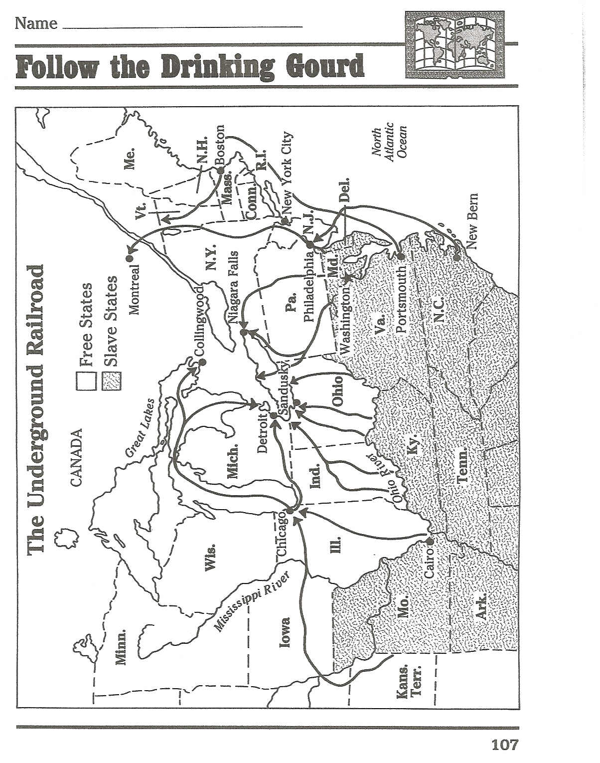

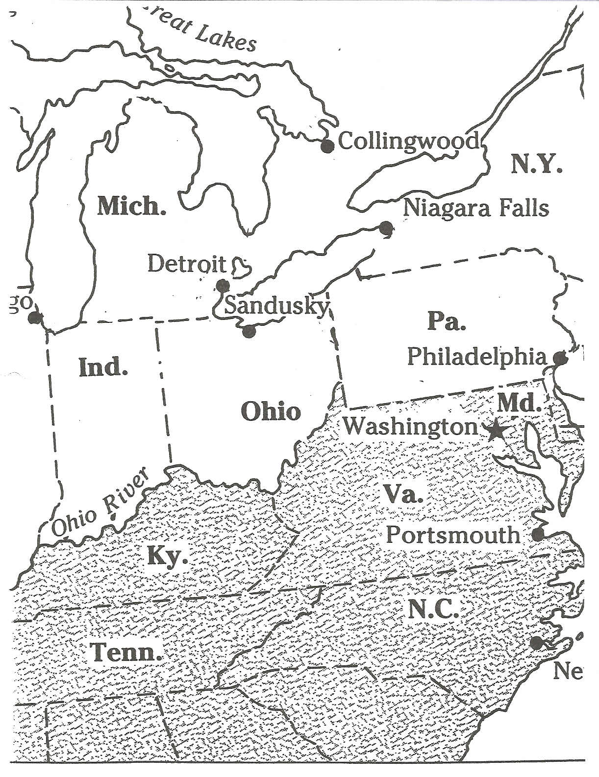

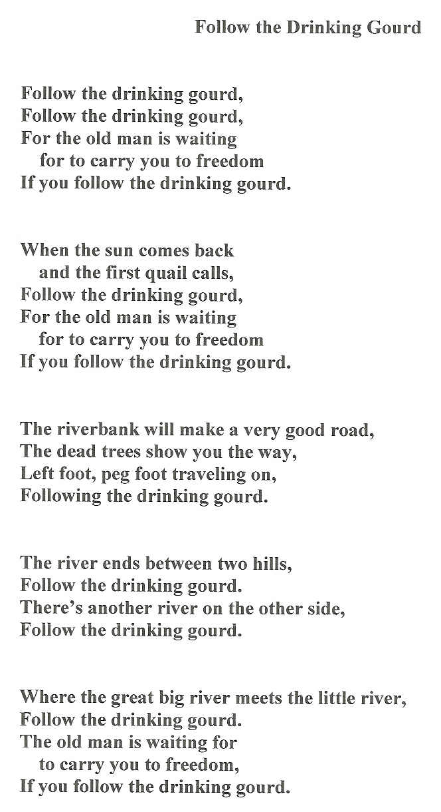

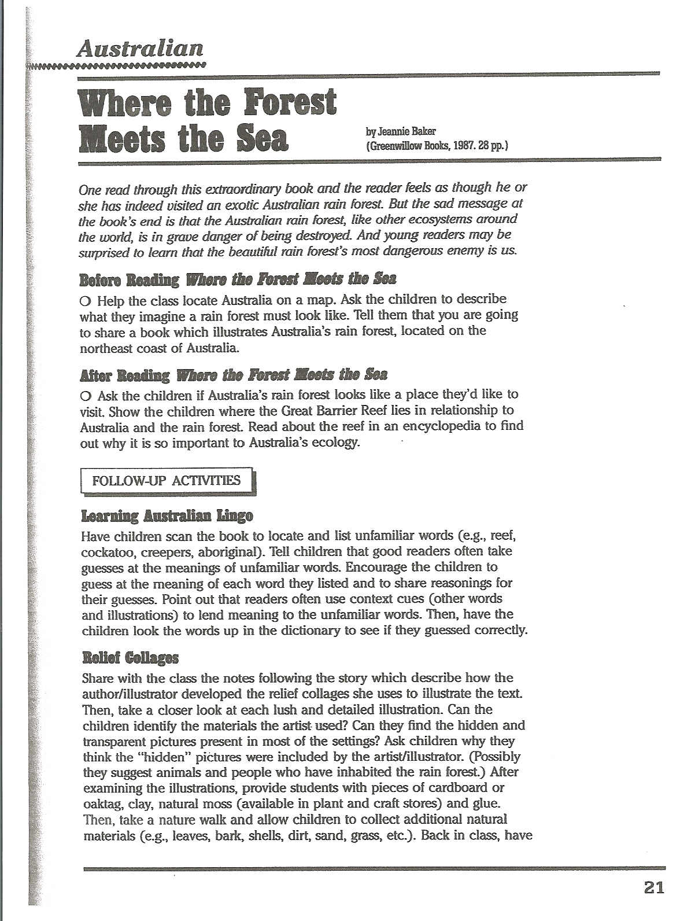

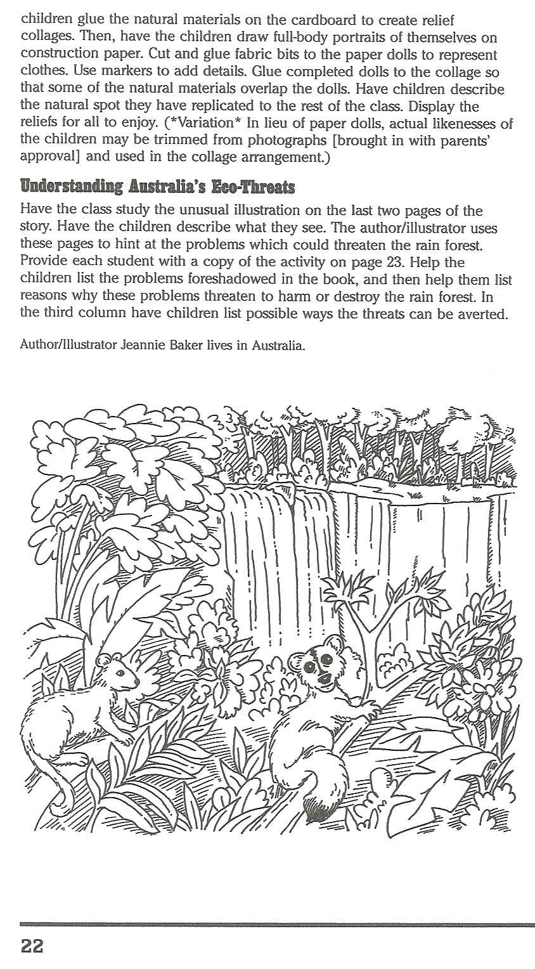
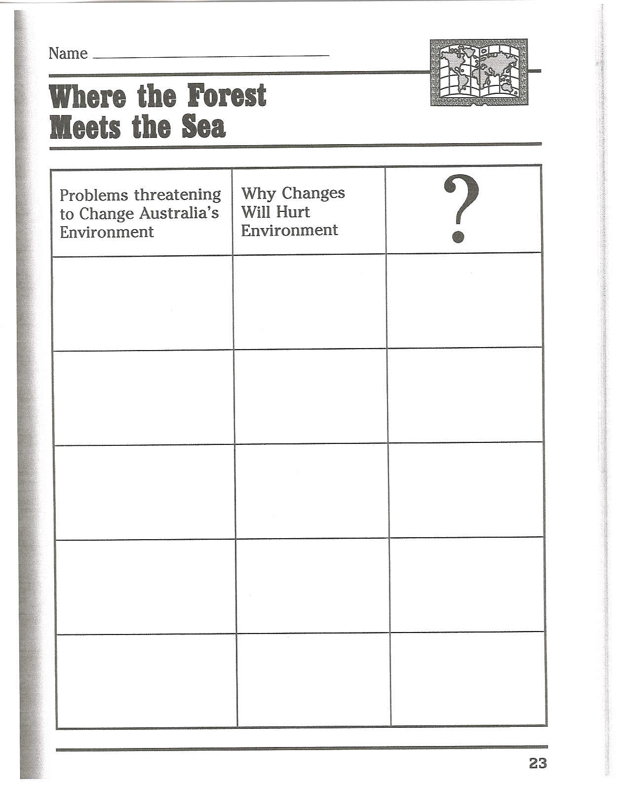

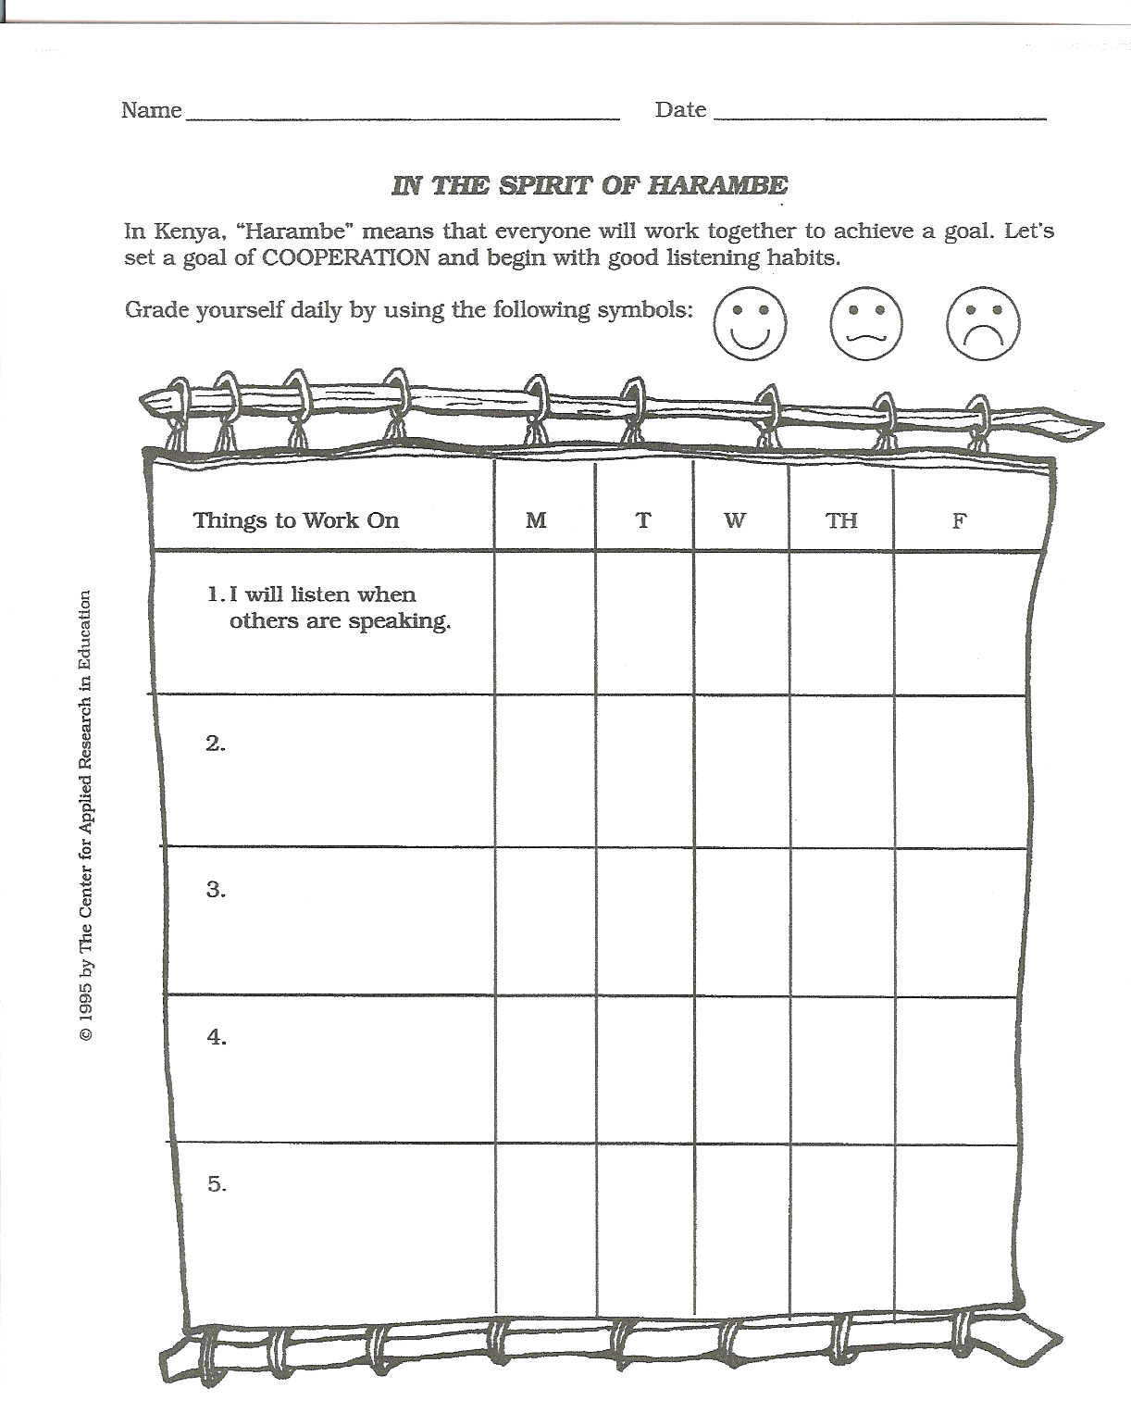

Candy Activity

Goal: To observe hidden bias in humans.

Objective: Participants will be made aware by demonstration that human tendency is to

steer away from the unknown.

Materials: Candy from three different cultures, wrapped accordingly.

Procedures:

- Each participant will select one piece of candy from a mixture of Chinese,

Mexican, and American candy. 2) The presenter will tally the number of people who

chose the Chinese, Mexican, and American candy. 3) The presenter will discuss the

number of each type of candy chosen which will show how human tendency is to

steer away from the unknown.

The least selected candy will probably be from the Chinese and Mexican cultures.

These candies are not of lesser quality or taste; they are just different in their appearance

and language. How does this activity correlate with our attitudes towards other cultures

and their appearances?

Getting Started – Respect Activity (Gorski, 2000)

Goal: To show people’s attitudes towards things can be different.

Objective: The participants will learn that not everyone see things the same way and that

it is alright to be different and have different views towards things.

Procedures:

Ask everyone to find someone in the room they do not know. Instruct them to introduce

themselves to that person, and spend five minutes talking about respect. What does it

mean for you to show respect, and what does it mean for you to be shown respect? After

the allotted time, ask the participants to return to their seats, and open the discussion.

What did the people come up with?

Be sure in the discussion that you mention that respect is a crucial ingredient in any

discussion, but especially in often-controversial issues regarding multicultural

issues. The point is to learn from our differences, to understand each other’s

understanding. The point is to NOT AGREE. Respect also includes keeping the

conversation in the group. This type of community building can make or break an

attempt to facilitate discussions on multicultural issues. This activity first creates the path

toward building a community of respect. The discussion maintains a constructive

exchange regarding issues such as racism, sexism, etc. Most participants meet someone

they did not know, and exchange ideas with that person. Second, the community is built

through the understanding of how the group perceives respect, and how they negotiate its

meaning. And last, the differences and similarities in the ideas shared about respect

begin to show the first signs of the differences and similarities within the group.

Exchanging Stories- Names Activity (Gorski, 2000)

Goal: To make others aware of origin of names.

Objectives: Participancts will discover where their name originated and where others

came from in the group. They will discover that although they may be culturally

different, their names may tie them together in some way.

Materials: paper, pencil, encyclopedia, or access to Internet.

Procedures:

This activity should be mentioned in advance so participants may research some of the

information ahead of time. Ask the participants to write a short story about their names.

Leave the assignment open to the individual’s interpretation as much as possible. If they

ask for more specific instructions, suggest some or all of the following possibilities for

inclusion in their stories.

Who gave you your name? Why

What is the ethnic origin of your name?

What are your nicknames?

What do you prefer to be called?

As always, encourage them to be creative. Everything is acceptable. Some may choose

to write a poem, while others may write humorous stories or character lists. It is up to

them what they choose to create. But make sure you tell them that they will be sharing

what they create with the rest of the class.

Sharing:

Ask for volunteers first. Some papers may have personal information they wish to

share. If the facilitator goes first, it tends to make others open up and want to share. Be

sure to allow time for everyone to speak. When everyone has shared, ask participants

how it felt to share their stories. Why is this activity important? What did they learn

about themselves, or about others in the group?

Workshop Evaluation

- How often do you integrate multicultural ideas and principals into the taught

curriculum?

- Every lesson
- Once a week/ couple of times a month
- On holidays and designated months
- Never

- After participating in the multicultural awareness workshop will you integrate more

multicultural ideas into the lessons?

- Yes, most definitely
- I will try some activities
- No

- What was the most beneficial part of the workshop?

- What was the least beneficial part of the workshop?

- Do you think your school does a good job of incorporating multicultural ideas at your school? If yes, please explain how this is accomplished.

- List 3 things you can do in your classroom to improve multicultural attitudes.

7. What suggestions do you have for this workshop?

Books on Multicultural Education for Curriculum and Teaching (Gorski, 2000)

Affect in the Curriculum: Toward Democracy, Dignity, and Diversity

Beane, J. A. New York: Teachers College Press, 1990.

The American Tapestry: Educating a Nation: A Guide to Infusing Multiculturalism into American Education

Alexandria, VA: National Association of State Boards of Education, 1991.

Assessment for Equity and Inclusion: Embracing All Our Children

Goodwin, A. Lin. New York: Routledge, 1997.

Beyond the Culture Wars: How Teaching the Conflicts Can Revitalize American Education

Graff, G. New York: W. W. Norton & Co., 1992.

Cooperative Learning in Diverse Classrooms

Putnam, JoAnne W. Paramus, NJ: Prentice-Hall, 1996.

Culture and Power in the Classroom: A Critical Foundation for Bicultural Education

Darder, A. New York: Bergin and Garvey, 1991.

The Dialogic Curriculum: Teaching and Learning in a Multicultural Society

Stock, Patricia L. Paramus, NJ: Prentice-Hall, 1993.

Empowerment through Multicultural Education

Sleeter, C. E., ed. Albany, NY: State University of New York Press, 1991.

An Introduction to Multicultural Education

Banks, J. A. Boston, MA: Allyn and Bacon, 1994.

Kaleidoscope: A Multicultural Approach for the Primary School Classroom

De Gaetano, Yvonne. Upper Saddle River, NJ: Macmillan, 1997

Making Choices for Multicultural Education: Five Approaches to Race, Class and

Gender. 2nd ed

Sleeter, C. E. and C. A. Grant. New York: Merrill, 1993.

Multicultural Education in a Pluralistic Society. 3rd ed

Gollnick, D. M. I. and P. C. Chinn. Paramus, NJ: Prentice- Hall, 1997.

A Post-Modern Perspective on Curriculum

Doll, William E. New York: Teachers College Press, 1993.

Other People's Children: Cultural Conflict in the Classroom

Delpit, Lisa. New York: The New Press, 1995.

Teaching for Diversity

Border, L. L. B. and N. V. N. Chism, eds. San Francisco, CA: Jossey-Bass, 1992.

Teaching in a Pluralistic Society: Concepts, Models, and Strategies. 2nd ed.

Garcia, R. L. Boston, MA: Addison-Wesley, 1991.

Teaching Stories

Logan, Judy. New York: Kodansha, 1993.

Teaching Strategies for Social Studies

Banks, J. A. 5th edition. Boston, MA: Wesley-Hodson, 1991.

Teaching to Transgress: Education as the Practice of Freedom

Hooks, Bell. New York: Routledge, 1994.

Teaching with a Multicultural Perspective

Davidman, Leonard and Patricia T. Davidman. 2nd ed. New York: Longman,

1997.

Web Sites for Multicultural Education (Gorski, 2000)

Intercultural E-mail Classroom Connections (http://www.iecc.org/)

"The IECC (Intercultural E-Mail Classroom Connections) mailing lists are provided by St. Olaf College as a free service to help teachers and classes link with partners in other countries and cultures for e-mail classroom pen-pal and project exchanges."

K-5 Cybertrail: Multicultural Curriculum Resources

(http://www.wmht.org/trail/explor02.htm)

Includes well-organized links to Resources for Teachers, Web sites for Kids,

E-Mail Exchanges, and Schools Around the World.

Multicultural Math (http://www.clarityconnect.com/webpages/terri/multicultural.html)

Includes multicultural math goals, links to multicultural math sites, and other related information.

Multicultural Pavilion (http://curry.edschool.virginia.edu/go/multicultural)

The Pavilion's mission is to "provide resources for educators to explore and discuss multicultural education; to facilitate opportunities for educators to work toward self-awareness and development; and to provide forums for educators to interact and collaborate toward a transformative, critical pedagogical approach to multicultural education." Resources include a Discussion Board, archives of online papers and essays, research and inquiry links, a tutorial for finding resources

online, and a list of links to online sources.

Multicultural Studies from the Social Studies School Service (http://www.socialstudies.com/)

"Social Studies School Service has been a leader in educational resources since

1965, searching out the highest quality supplementary learning materials, including books, CD-ROMs, videos, laserdiscs, software, charts, and posters. Our experienced editorial staff and teacher consultants carefully evaluate titles from over a thousand publishers, searching for materials that are effective, balanced, easy to use, and reasonably priced. In our ongoing effort to respond to the needs of teachers, we publish over 30 catalogs a year (focusing on different subject areas and grade levels) that list the best materials for you using short, informative, and objective descriptions."

National Alliance for Media Arts and Culture

(http://www.igc.apc.org/namac/index.html)

The main Web site for NAMAC will be very useful for anyone who is trying to find a source for films, or for organizations devoted to media, education and social justice. NAMAC provides a very extensive listing of both national and local organizations, both alphabetically, and by state.

National Civil Rights Museum (http://www.midsouth.rr.com/civilrights/)

Information regarding the museum in Memphis, Tennessee. Also includes a Virtual Tour of the museum with text and photographs.

Standards: An International Journal of Multicultural Studies (http://stripe.Colorado.EDU/~standard)

An online journal dedicated to multicultural studies, with a different theme for every issue. See vol. 6 no. 1 for "Education."

Vandergrift's Children's Literature Page (http://www.scils.rutgers.edu/special/kay/childlit.html)

An acquaintance with and an understanding of literary characters is one of the

first ways a young child has of making sense of what it is to be human." Kay

Vandergrift offers a myriad of wonderful resources pertaining to children's

literature, including lists of books with positive portrayals of African Americans,

Native Americans, Asian Americans, and Hispanic Americans. She also includes

a list of books with positive portrayals of women.

References

Burnett, G. (1994). Varieties of multicultural education: An introduction. V98.

(Report No. ISSN 0889 8049) ERIC Clearinghouse on Urban Education, New York,

N.Y.

Gollick, D., & Chinn, P., (1998). Multicultural education in a pluralistic society.

Columbus, Ohio: Prentice Hall.

Gorski, P., Green, M., & Shin, G. (2000). The multicultural resource series:

Professional development guide for educators. (V1). Annapolis Junction, MD: NEA

Professional Library.

Gomez, R. (1991). Teaching with a multicultural perspective. (Report No. EDO-

PS-91-11) Office of Educational Research and Improvement. (Contract No.OERI 88-

0620-12) Champagne, Illinois.

Paschal, K. (2001). Student demographics in midlothian independent school

district. Midlothian, Texas: Midlothian I. S. D.

Spann, M. (1992). Literature based multicultural activities: An integrated

approach. New York: Scholastic Professional Books.

